**ANALYSIS OF SECURITY IN COMPUTER GAMES THROUGH THE DEMONSTRATION OF VARIOUS THREATS**

**A PROJECT REPORT**

***Submitted by***

**Aditi Kurutala**(20BCY10006)

**Ajinkya Bhanpurkar**(20BCY10008)

**Avantika Krishnan** (20BCY10028)

**Arundhati Menon** (20BCY10031)

*in partial fulfillment for the award of the degree of*

**BACHELOR OF TECHNOLOGY**

*in*

**COMPUTER SCIENCE and ENGINEERING**

**(SPECIALIZATION IN CYBER SECURITY AND DIGITAL FORENSICS)**



**SCHOOL OF COMPUTING SCIENCE AND ENGINEERING**

**VIT BHOPAL UNIVERSITY**

**MADHYA PRADESH - 466114**

JUNE 2022

**VIT BHOPAL UNIVERSITY, KOTHRI KALAN, SEHORE**

**MADHYA PRADESH – 466114**

**BONAFIDE CERTIFICATE**

Certified that this project report titled**Analysis of security in computer games through the demonstration of various threats** is the bonafide work of **Aditi Kurutala (20BCY10006), Ajinkya Bhanpurkar (20BCY10008), Avantika Krishnan (20BCY10028), Arundhati Menon (20BCY10031)** who carried out the project work under my supervision. Certified further that to the best of my knowledge the work reported at this time does not form part of any other project/research work based on which a degree or award was conferred on an earlier occasion on this or any other candidate.



**PROGRAM CHAIR PROJECT GUIDE**

Dr. R. Rakesh, Assistant professor Mr.Vikas Kumar Jain, Assistant professor

School of Computer Science and Engineering School of Computer Science and Engineering

The Project Exhibition II was held on 23 April 2022

**ACKNOWLEDGEMENT**

First and foremost, I would like to thank the Lord Almighty for His presence and immense blessings throughout the project work.

I wish to express my heartfelt gratitude to Dr. S. Poonkuntran, Head of the Department, School of Computer Science and Engineering for much of his valuable support and encouragement in carrying out this work.

I would like to thank my internal guide Mr. Vikas Kumar Jain, for continually guiding and actively participating in my project, and giving valuable suggestions to complete the project work.

I would like to thank all the technical and teaching staff of the School of Computer Science and Engineering, who extended directly or indirectly all support.

Last but not least, I am deeply indebted to my parents who have been the greatest support while I worked day and night on the project to make it a success.

**i. LIST OF ABBREVIATIONS**

|  |  |
| --- | --- |
| **ABBREVIATION** | **EXPLANATION** |
| MMOG | Massively Multiplayer Online Game |
| CDN | Content Delivery Network |
| AR/VR | Augmented reality and Virtual reality |
| MMORPG(s) | Massively Multiplayer Online Role-Playing game(s) |
| DDoS | Distributed Denial of service |
| OTP | One time Password |
| MD5 | Message Digest 5 |
| DRM | Digital Rights Management |
| DLC | Downloadable Content |
| UDP | User Defined Protocol |
| DNS | Domain Naming System |
| VPN | Virtual Private Networks |
| GRE | Generic Routing Encapsulation |
| SOA | Service Oriented Architecture |
| RP | Ranked Points |
| NNID | Nintendo Network Identification |

**ii. LIST OF FIGURES AND GRAPHS**

|  |  |
| --- | --- |
| **Figure No.** | **Title** |
| **1.1.2.1** | Statistics for first quarter of 2020 to second quarter of 2021 |
| **1.1.3.1** | Increase in number of DDoS attacks |
| **1.1.3.2** | Statistics of Identity Theft cases in USA |
| **1.1.3.3** | Statistics of occurrence of Cyberbullying in different countries |
| **2.2.1** | Technological Risks |
| **2.2.2** | Social Risks |
| **2.2.3** | Graphical depiction of countermeasures |
| **2.2.4** | Rise observed in the number of cybercrimes in India |
| **2.2.5** | Statistics of the time spent by youngsters of different countries in gaming |
| **2.2.6** | Different types of online games |
| **2.2.7** | Types of Cybercrimes in online gaming |
| **2.2.8** | Steps involved to infiltrate through the security precautions |
| **2.2.9** | Authentication mechanisms |
| **2.2.10** | Kerberos Authentication System |
| **2.2.11** | Threat of unneeded data flooding |
| **2.2.12** | Security Tree for MMOG |
| **2.2.13** | Representation of different types of cheating |
| **3.2.1.1** | Dummy website |
| **3.2.1.2** | Performing attack using HULK |
| **3.2.1.3** | Analyzing packets using Wireshark |
| **3.2.2.1** | Code snippet 1 |
| **3.2.2.2** | Code snippet 2 |
| **4.2.1.1** | Message shown by Ragnar Locker in a compromised device |
| **4.2.1.2** | Timeline of the attack |
| **4.2.2.1.1** | Steps in a DDoS attack |
| **4.2.2.1.2** | Streamers tweet about the issues faced |
| **4.2.2.1.3** | Tweet about the updates in games by Respawn entertainment |
| **4.2.2.2.1** | Squid game |
| **4.2.2.2.2** | Map showing Andorra |
| **4.2.2.2.3** | Internet connectivity and the fluctuations |
| **5.2.1** | What in your opinion is the most popular online game? |
| **5.2.2** | How safe in your opinion, is the game mentioned in the previous question? |
| **5.2.3** | What does the term online gaming security mean? |
| **5.2.4** | Cybercrimes related to online games are on the rise with many gamers being a victim of different cyber-attacks. What attack is the most prominent that endangers the security of any user interacting through an online server? |
| **5.2.5** | In march of 2021, the sensational multiplayer game Apex legends faced a major security compromise which is common to most multiplayer games online. What was the security compromise? |
| **5.2.6** | Which Cyber-attack affected the Minecraft server? |
| **5.2.7** | What are the necessary steps to safeguard their data? |
| **5.2.8** | What attack locks and encrypts data and can be decrypted only by payment? |
| **5.2.9** | How can a gamer safe-keep their online presence in cyberspace |
| **5.2.10** | A Trojan Attack |
| **5.2.11** | Phishing Attacks |
| **5.2.12** | Have you ever faced any attacks? |

**iii. LIST OF TABLES**

|  |  |
| --- | --- |
| **Table no.** | **TITLE** |
| **2.2.1** | Game Specific Security Practices |
| **2.2.2** | Attacks propagated through online gaming servers |
| **2.2.3** | Countermeasures against notorious cyberattacks |
| **2.2.4** | Difference between the six authentication mechanisms |
| **2.2.5** | Categorizing the types of attacks |
| **2.2.6** | Some infamous cyber attacks |
| **2.2.7** | Cheating Techniques |
| **2.2.8** | Summary of literature reviews |
| **4.2.3.1** | Three possible scenarios |

**ABSTRACT**

Online gaming security is a dynamically emerging research domain attracting interest. Online gaming service providers are essentially required to detect and prevent many security hazards. These risks substantially exist in popular multiplayer games that allow for the monetization of cyber assets. Monetization of cyber assets and exposure of user information has made the online gaming community vulnerable to cyber-attacks. Awareness of proper and functional mitigation techniques has become a need of the hour.

In this project, we examine academic research efforts and industry practices connected to the threats involved in online gaming. We also observe real-life scenarios and compromises through the demonstration of minuscule attacks to highlight the impact of security threats on gaming servers and systems. Through the results obtained from a survey, we shall highlight the awareness of the general public on the spiking security attacks that are targeted at the users using online gaming servers and chat rooms as a medium of propagation. To conclude we shall include case studies and derive inferences from the past attacks that have paved a path for better security mechanisms which are adopted by game developers and players alike.

**TABLE OF CONTENTS**

|  |  |
| --- | --- |
| **CHAPTER No.** | **TITLE** |
| i.  ii.  iii.  iv. | List of Abbreviations  List of figures and Graphs  List of Tables  Abstract |
|  | **CHAPTER-1**  **PROJECT OUTLINE AND DESCRIPTION**  1.1 Introduction  1.1.1 What are online games?  1.1.2 Rising security issues in Online games  1.1.3 Cyber threats in online gaming servers  1.2 Motivation for the work  1.3 About project  1.4 Proposed work  1.5 Objective of work  1.6 Organization of work  1.7 Summary |
|  | **CHAPTER-2**  **RELATED WORK INVESTIGATION**  2.1 Introduction  2.2 Literature Review |
|  | **CHAPTER 3**  **DESIGN METHODOLOGY AND ITS NOVELTY**  3.1 Introduction  3.2 Implementation techniques  3.2.1 DoS attack  3.2.2 Clipboard hijacking |
|  | **CHAPTER 4**  **TECHNICAL IMPLEMENTATION & ANALYSIS**  4.1 Introduction  4.2 Case Study  4.2.1 Case Study 1 - Ransomware Attack  4.2.2 Case Study 2 - DDoS Attack  4.2.3 Case Study 3 - Data Breach |
|  | **CHAPTER 5**  **PROJECT OUTLINE AND APPLICABILITY**  5.1 Introduction  5.2 Survey |
|  | **CHAPTER 6**  **CONCLUSION AND RECOMMENDATION**  6.1 Outline  6.2 Limitations and constraints in the research  6.3 Future Enhancements  6.4 Inference |

**CHAPTER - 1**

**PROJECT DESCRIPTION AND OUTLINE**

**1.1 INTRODUCTION**

The onset of the digital era has seen a healthy increase in the number of users spending their time of leisure in cyberspace through computer game servers and chat rooms. This digitalization has entailed the rise of huge gaming companies which, with the help of gaming engineers and creators, have revolutionized entertainment and recreational time for all.​

The gaming platform has recently seen a spiking rise in the number of cyberattacks, some over minor problems of spite and envy while others as a medium to propagate irrational and threatening ideologies. This problem has and is bound to become severely critical over the course of time. Thus, awareness regarding the cyberattacks spread through computer games and the precautionary measures one can take against such attacks has become extremely crucial.​

According to the leading CDN company Akamai, the gaming industry, in recent years, has been the biggest victim of cyberattacks. Present-day statistics suggest around 2.77 billion people around the globe are involved in computer gaming. In an era of digitization, the progress in AR/VR technology, and the shift towards virtual environments, it becomes crucial to provide a secure gaming experience. The severity of cyber threats has made awareness regarding cyber-attacks on online gaming servers and measures one can take against them particularly vital.

**1.1.1 What are Online games?**

In layman’s terms, an online game is a video game that is played in part or entirely over the Internet or any other available computer network. The rise in the popularity of online games skyrocketed with the debut of **Islands of Kesmai** which was released by the game developers at CompuServe in 1984 as the first commercial multiplayer online role-playing game. The extensive reach of the Internet throughout the globe continued to add to the glory of online games with people enjoying the environment created by game franchises like **Counter-Strike (1999), World of Warcraft (2004), League of Legends (2010), Fortnite Battle Royale (2017)**, etc. Today the online gaming industry is dominated by MMORPGs like **Valorant, Apex legends, Overwatch**, etc**.**

**1.1.2 Rising security issues in Online games**

During the COVID-19 pandemic period, people formed online groups and communities to stay connected with each other and enjoy their leisure time on the internet by commuting over online game servers and chat rooms. The increasing popularity of MMORPGs has shifted the balance of internet and information security once again. We have observed a spiking rise in the number of security compromises that have preyed upon victims by using online gaming platforms as a medium to spread malicious computer codes and malware during the pandemic period. **Graph 1.1.2.1** shows the number of malicious files, disguised as executable game files, that were distributed among the online users during the first quarter of 2020 to the second quarter of 2021.

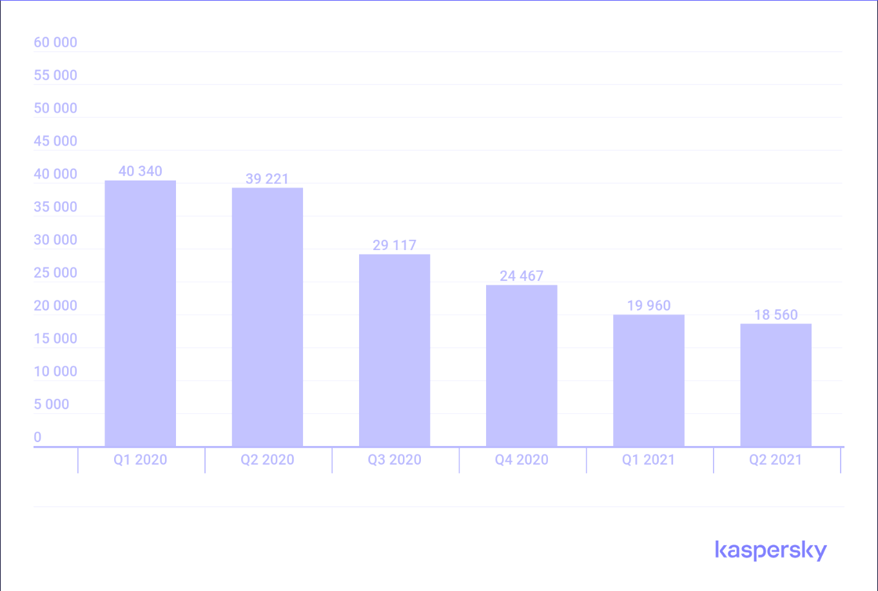

**Figure 1.1.2.1:** Statistics for first quarter of 2020 to second quarter of 2021

It is clearly observed that the threat of data breach and loss of personal information at the hands of a malicious hacker is not a possibility but a bitter reality in cyberspace today.

**1.1.3 Cyber threats in online gaming servers**

Recent analytics reveal that the most common threat posed to an online gamer is being exposed to DDoS attacks. According to the statistical analysis provided by Cloudflare, a DDoS mitigation company, Ransom DDoS attacks, a DDoS assault in which the attacker threatens the server owner or demands a ransom, increased by 29 percent year over year. Furthermore, according to Cloudflare, the gaming business was the second most targeted industry for Layer 7 DDoS attacks. For the fourth quarter of 2021, this accounted for 0.034 percent of the industry's overall traffic. **Graph 1.1.3.1** provides a detailed insight on this staggering increase in the number of DDoS attacks and its impacts on different industries.

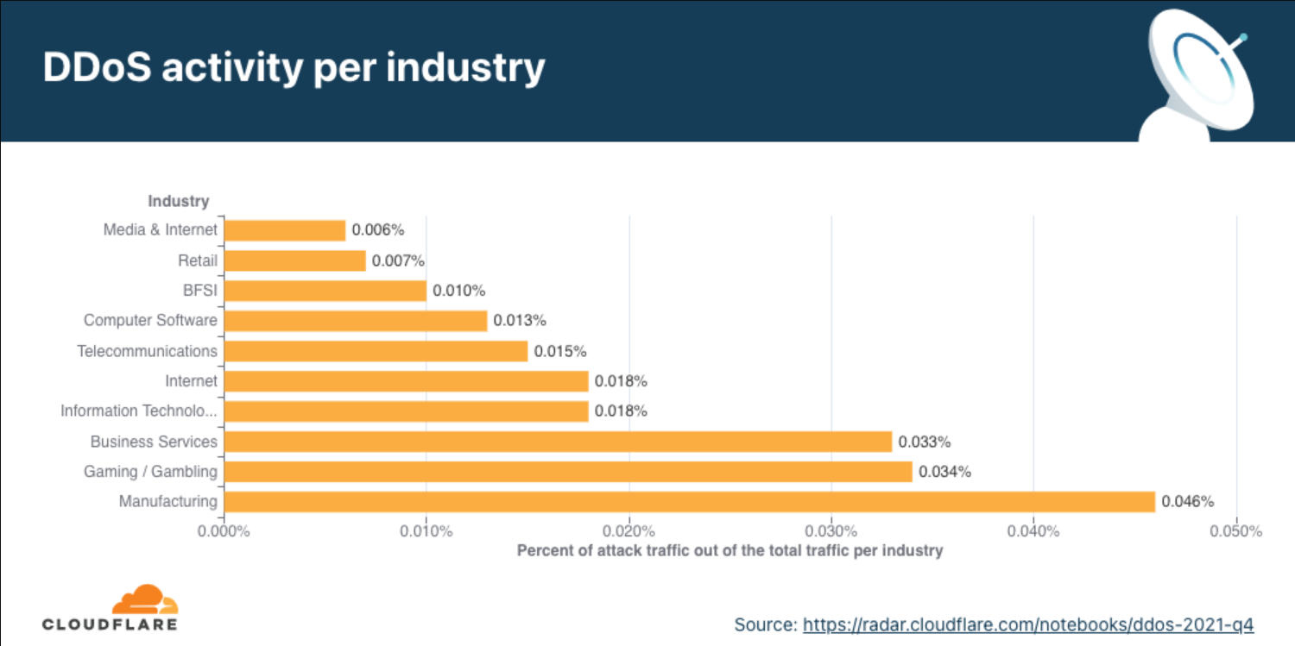

**Figure 1.1.3.1:** Increase in number of DDoS attacks

Some other common threats to users and players in the gaming world are enlisted below:

1. **Ransomware**

Ransomware is a malware that restricts access by encrypting files in an attempt to extort money or ransom, usually in the form of cryptocurrency. This cyber threat is an increasingly rising global issue. Constant modifications and advancements made to safeguard user information make older platforms susceptible to ransomware attacks.

1. **Identity theft**

Identity theft is the second most common threat faced by gamers and players of MMORPGs. Identity theft for gamers involves malicious hackers impersonating a genuine player on the gaming server and jeopardizing his/her online presence by disrupting the gaming server or getting involved in illegal activities. **Graph 1.1.3.2** shows the reported identity theft cases recorded in the USA.

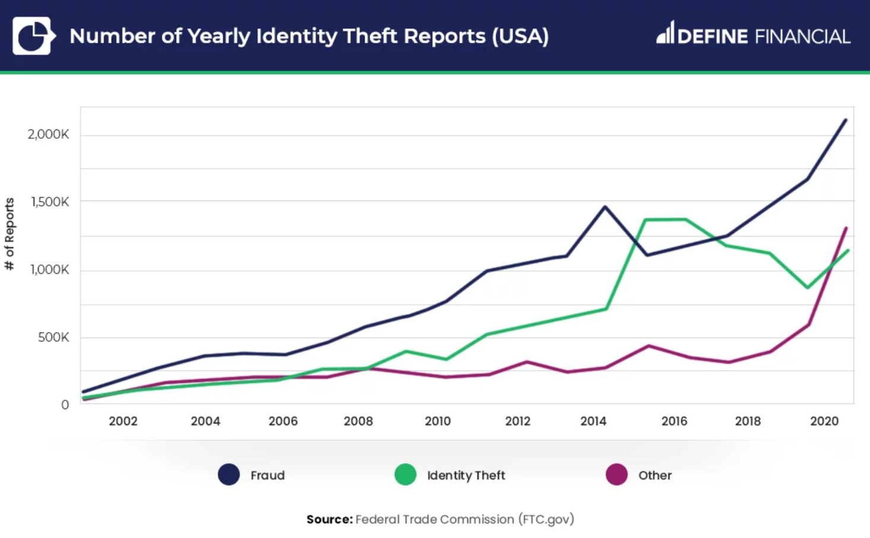

**Figure 1.1.3.2:** Statistics of Identity Theft cases in USA

1. **Data breach**

A data breach occurs when information is stolen or removed from a system without the owner's knowledge or authority.

1. **Phishing**

Phishing is an attempt to steal your money or identity by tricking you into revealing personal information on websites that appear to be legitimate, such as credit card details, bank account numbers, or passwords.

1. **Cyber bullying**

Cyberbullying, also known as cyber harassment, is an electronic form of bullying or harassment. Online bullying includes cyberbullying and cyber harassment. As the digital environment has grown and technology has evolved, it has become more widespread, particularly among youth. **Graph 1.1.3.3** shows the data collected on the prevalence and occurrence of cyberbullying in different countries.

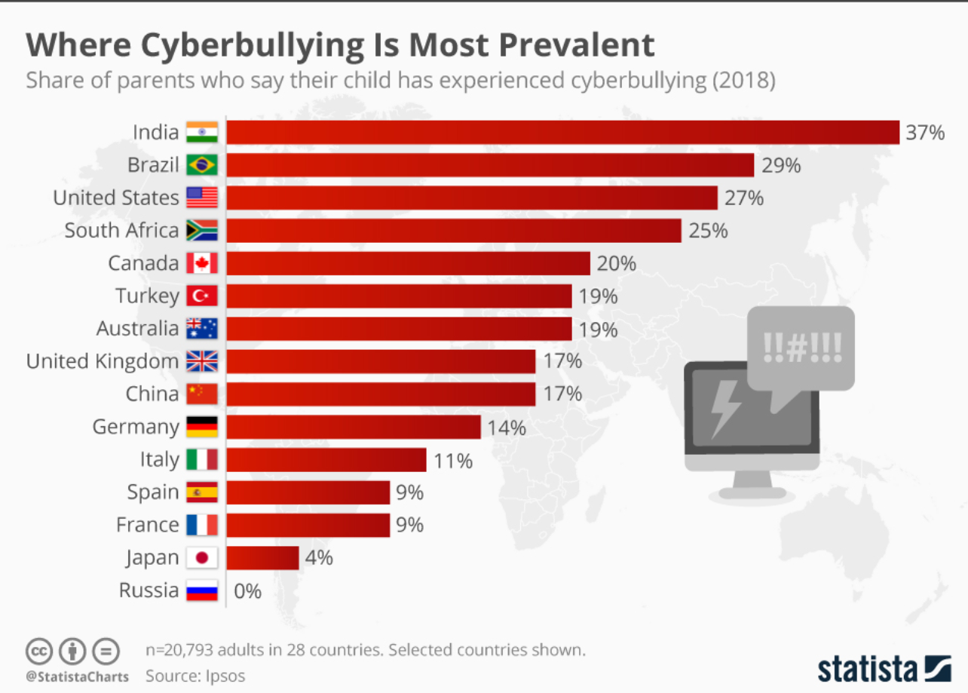

**Figure 1.1.3.3:** Statistics of occurrence of Cyberbullying in different countries

1. **Gold farming**

Gold farming is an online gaming community specific threat. In layman’s terms, gold farming is the act of playing a game repeatedly in order to accumulate stocks of the game's virtual currency or other valuable commodities that can subsequently be sold to other players for real money.

**1.2 MOTIVATION FOR THE WORK**

Recent times have seen a surgical expansion in the number of ransomware attacks globally, raising multiple issues concerning the security of one’s confidential information in the digital world. Financial gains, disrupting crucial public or private services, or destabilizing a firms' network are few of the major intentions of malicious hacker groups who propagate dynamic and alternating variants of crimes through online gaming servers to cause panic and chaos all over the world and specifically the virtual communities.

As computer engineering students pursuing cyber security as a specialization, it is crucial to understand the basis and premises under which a particular cyber-attack on a system or network of systems is carried out and to prevent large-scale disruptive attacks on pivotal organizations. In order to fulfill this assignment and perform necessary duties towards our goal of a secure computer network, we must be aware of the past and present of the problem in order to shield ourselves and prepare proper arrangements for the future.

**1.3 ABOUT PROJECT**

Through this research-based project our team aims to highlight the rise in the security issues that are observed in online gaming servers, chat rooms, and communities by reviewing various research papers from renowned authors and professors along with conducting a survey to spread awareness regarding the spiking rise of cyberattacks propagated through MMORPGs.

The project aims to highlight the concurrent impact of computer games on our lives and how large-scale security compromises surrounding gaming servers jeopardize the private data of the people socializing and interacting in cyberspace through chat rooms provided by the gaming servers. The implementation of a minuscule attack will help us understand the threats and vulnerabilities of a gaming server and help us pave a possible path so as to configure a defense strategy against such attacks.

This will assist us to comprehend the different methods used by malicious hackers to attack a server or website and the safeguarding strategies to adopt if and when a server or application is under the influence of a cyber-attack.  
**1.4 PROPOSED WORK**

Our team proposes extensive research of the security of computer games through a series of case studies followed by comprehensive study of existing research papers compiled in the form of literature reviews and a survey on the general awareness of the public on the security compromises in computer games.

We shall also highlight the minuscule version of some of the attacks on a multiplayer game server and explore precautionary measures one must adopt to safeguard their data and system from the prying eyes of malicious hackers.

**1.5 OBJECTIVE OF WORK**

Seeing the exponential peak in the number of security compromises to user data through malicious links and attachments embedded in computer game servers and executable files, our team aims to conduct an extensive and in-depth analysis of the robustness of security protocols followed by computer games to ensure a safe experience for the user.

**1.6 ORGANIZATION OF WORK**

The project is divided into various components among which are a collective review of authentic and riveting research papers from the past decade on the cybersecurity aspect of online games and the impacts data breaches and recent security compromises that are faced by the virtual communities and developers along with a general awareness survey conducted by the team members to captivate the audience and help them enhance their awareness around online games and their security. Analytical case studies were also researched upon and mentioned in the paper to give an insight into the scale of the attacks that the game developing organizations faced along with discussing mitigation measures which can be adopted to safeguard user information.

**Chapter 1** deals with the project introduction by providing a detailed account into the meaning behind the term online games, virtual communities and how the evident security issues can pose a great deal of threat to the players and organizations in the future. Common threats along with relevant and recent demographics are elaborated in the chapter.

**Chapter 2** provides detailed inspection and review of contemporary research papers released on online gaming and forms a bridge linking the cybersecurity aspects to the gaming world. The observations are established through graphs, flowcharts and figures created by the team members.

**Chapter 3** aims to clearly establish the need for full-proof security measures in the gaming field and this will be done through the implementation of miniscule versions of two of the most concerning cyberattacks faced by gaming communities- DoS and Clipboard hijacking.

**Chapter 4** highlights the technical implementations discussed in chapter 3 of our report through analytical case studies completed with graphs, tables, and demographics.

**Chapter 5** spotlights the results of a general survey conducted by the team members on the awareness of the public on the growing problems and threats posed by MMORPGs. The results were collected through a Google form created by the team members and were accumulated in the form of pie charts and bar graphs.

**Chapter 6** draws conclusion to the report by summarizing the crucial points covered in the report and provides precautionary measures to help undo the after-effects of an attack carried out by exploiting an online game server.

**1.7 SUMMARY**

This project report will highlight an elaborative study of security issues in online games and establish a need of awareness among people regarding safety concerns on a gaming server through surveys, graphs, recent statistics, and in-depth analysis and explanation in a real-world context.

**CHAPTER - 2**

**RELATED WORK INVESTIGATION**

**2.1 INTRODUCTION**

Under this section we reviewed existing papers on online games and its security characteristics that will provide us with an insight into our own topic. We analyzed various papers belonging to a variety of categories related to online games and how virtual communities formed on the MMORPG platforms are exposed to various threats and vulnerabilities of the game server. This study will help us gain knowledge about the changes that are required to ensure information security, and make us realize the threat compromises in security poses to our future.

In view of Literature Review, our project requires us to go through a multitude of research papers and surveys surrounding the security aspect of the gaming arena, conducted by renowned cyber security companies and multiple researchers with publications in reputed journals.

**2.2 LITERATURE REVIEW**

Online gaming has become a favorite pastime of people as it is stated correctly by Eric J. Hayes[1]. While some view it as a hobby, some use it for mischief, giving rise to many risks. Massive multiplayer games are popular, and most of the time, these are the target of attackers. Sometimes these game characters and properties pass into the real world and are sold on various platforms like eBay for real-world money. The use of real money has given rise to virtual crime. In this paper, the technological and social risks have been assessed. The following diagrams **Fig. 2.2.1** and **Fig. 2.2.2** contains the synopsis of it.

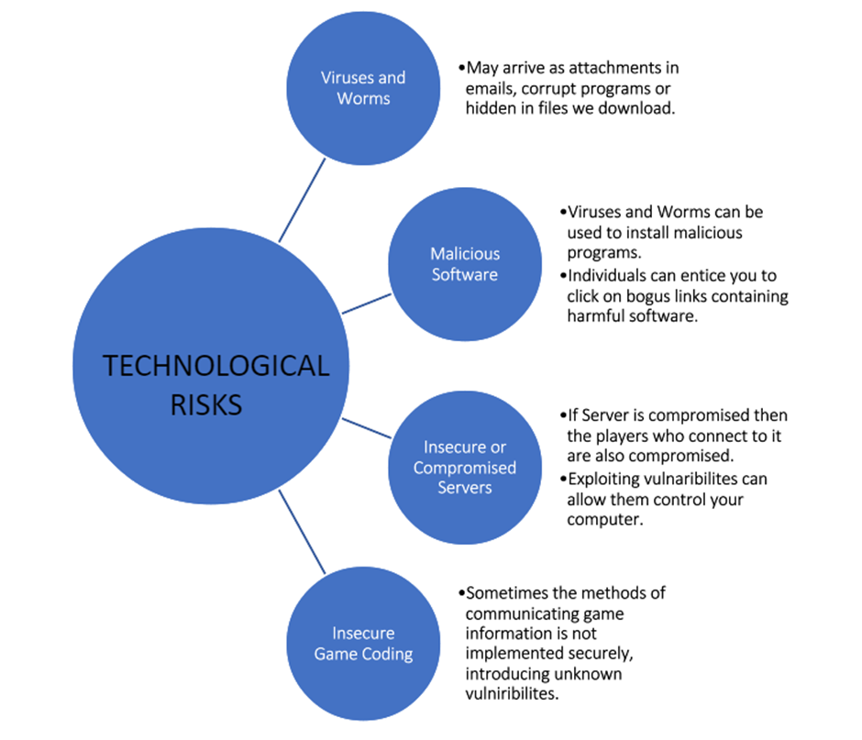

**Figure 2.2.1:** Technological Risks

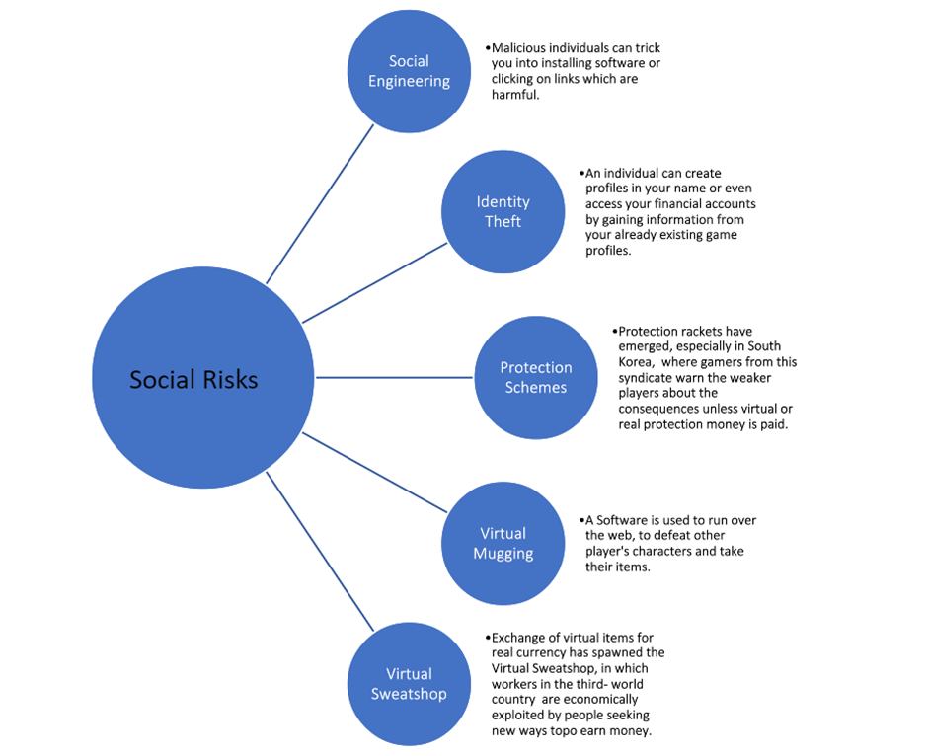

**Figure 2.2.2 :** Social Risks

The paper analyses and tells us some general ways to protect ourselves -:

* Use of Antivirus, Antispyware and Firewall programs.
* Creating and using strong passwords.
* Constantly updating and patching applications.
* Verifying the authenticity and security of downloaded files.
* Identify and backup personal and file data.

Certain game-specific security practices have also been investigated. The following table **2.2.1** shows us a summary of the same: -

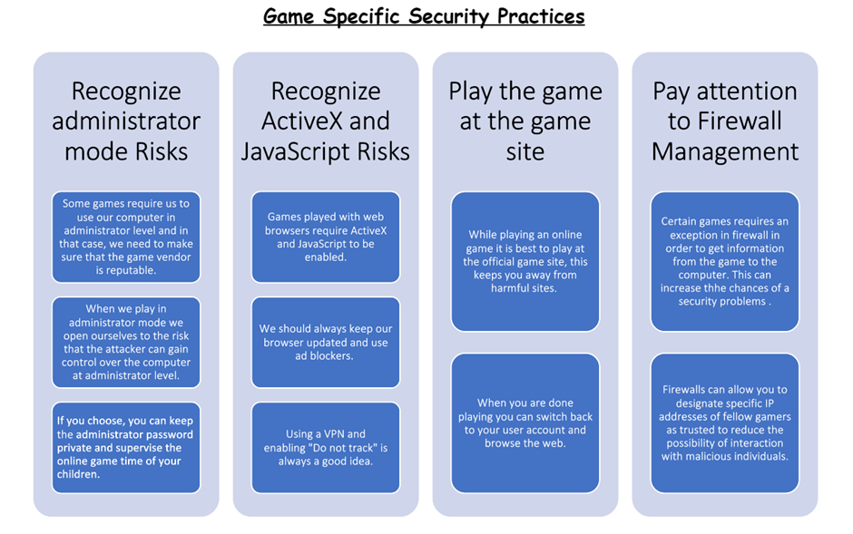

**Table 2.2.1:** Game Specific Security practices

A multitude of risks involved in online games have forced us to reconsider spending our time of leisure safely on the online gaming platforms. Internet criminals have devised several strategies for exploiting and profiting from online gaming providers. Hackers, industrialized illicit companies employing gold farmers (also known as game sweatshops), and even non-industrialized individual users are among the assailants. The research paper by Jiyoung Woo et.al [2] mentions that the goal of online game security is to safeguard data sets associated with online game services, such as game server systems, network devices, databases, and apps. Furthermore, online game security seeks to protect consumers' personal information and cyber assets from cheating and various hacking attempts, including identity theft (i.e., account theft).

To enhance countermeasures against these illicit behaviors in online games, a thorough understanding of current industry preventive approaches and current state-of-the-art research efforts is required. In addition, the gaps between current cheating actions and their defenses must be identified.

**Major threats and countermeasures in online games**

One of the most important aspects of an MMORPG is the virtual economy. The link between the virtual and real economies, on the other hand, fuels virtual crime and raises security concerns in online games. One of the most troublesome aspects of online gaming security is gold farming. Gold farming is the illegal practice of gathering virtual items in online games for the purpose of selling them for real money.

Although it is an endless battle, online game service providers recognize the significance of the damage caused by gold farmers and attempt to prohibit their actions. The several other categories of attacks that are propagated through the online gaming servers and chat rooms is depicted in **Table 2.2.2**

|  |  |  |  |
| --- | --- | --- | --- |
| **Category** | **Description** | **Effect on game service providers** | **Effect on users** |
| **Game bot** | * A game bot is an automated program that takes the place of a human when playing games. * Game bots can be divided into three types based on their physical characteristics: software, USB, and mouse. * Game bots can also be divided into two types based on how they run: out-of-game (OOG) client bots and in-game (IG) client bots. | Severity is high | Severity is high |
| **In-game hack** | * An in-game hack is when a player manipulates a computer's memory and game process(es) to gain an advantage. * (Memory hacks, speed hacks, HP hackers, wall-hacks, aim-hacks, and so on are examples of hacks.) | Severity is high | Severity is high |
| **Gold farming** | * Highly mechanized game sweatshops are used to mine gold. * There are two forms of gold farming: labor intensive and automated. * Human employees are used in labor-intensive gold farming games. * Highly designed gaming bot programs are used in automated gold farming. | Severity is high | Severity is high |
| **Private servers** | There are two sorts of private servers:   * Servers developed by reverse engineering study (emulated version, unrelated to hacking occurrences). * Servers that look exactly like the real item (typically obtained through a system compromise or internal file leak). | Severity is high | Severity is low |
| **System or network hacking** | * These are remote exploit attacks directly targeted at the game's servers, especially the database system that contains users' in-game cyber assets and equipment data. * Once this hacking has succeeded, hackers usually run an update query to manipulate the asset or inventory records. | Severity is high | Severity is medium |
| **Identity theft(account theft)** | * In this attack, the attacker uses stolen user accounts to log in. * Malware (such as dropper or password stealer) facilitates this assault. | Severity is medium | Severity is high |
| **Miscellaneous** | * In-game forgery or hoax. * In-game spamming. * Harassment. | Severity is low | Severity is low |

**Table 2.2.2:** Attacks propagated through online gaming servers

Identity theft is the most serious risk stemming from player fraud. Identity theft takes many forms. Hackers may gain access to prominent but insecure online sites and introduce harmful code. The dangerous code then spreads to unpatched home computers. Usernames and passwords are stolen by this malicious malware. Hackers can also gain direct access to personal data via breaching computer networks, systems, and databases. Client-side prevention methods are commonly used to safeguard consumers from being infected by malicious programs aimed at obtaining user ids and passwords. These client-side prevention methods include adopting different mechanisms to enhance the security of the client-side computer or device.

**Countermeasures against major threats**

With the spiking rise in the number of cybercrimes occurring per year, effective countermeasures and prevention steps have become the need of the hour. **Table 2.2.3** mentions a few countermeasures against notorious cyberattacks against client systems and game servers.

|  |  |
| --- | --- |
| **Category** | **Countermeasures** |
| **Game Bots** | Client-side: Install bot detection programs.  Network-side: Protect network traffic.  Server-side: Data mining and analysis to find out game bots' play patterns. |
| **In-game hacks** | Client-side: Install game security solutions.  Server-side: Implement investigation code that inspects all incoming packets. |
| **Gold farming** | Installation of bot detection programs. |
| **Private servers** | Implement a private server detection module. |
| **System or network hacking** | Enforce system and network security. |
| **Identity theft** | Enforce individual PC security or provide multi-factor authentication. |
| **Miscellaneous** | Enforce in-game monitoring by game masters (GMs) |

**Table 2.2.3:** Countermeasures against notorious cyberattacks

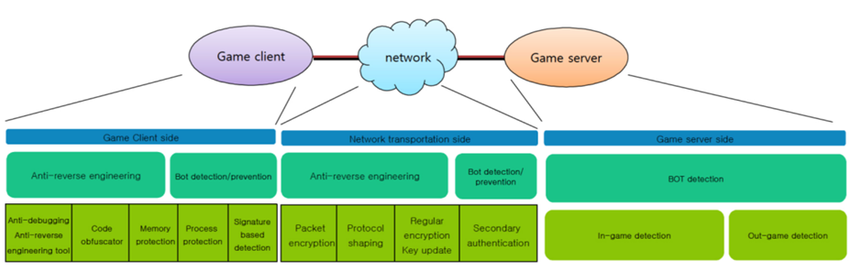

**Figure 2.2.3:** Graphical depiction of countermeasures

**Figure2.2.3** shows the graphical depiction of countermeasures that can be adopted by client-side, server-side, and network-side systems to incorporate user security and prevent extortion of money and other crimes that are facilitated through online game servers.

With the growth in the outreach of internet technology, we have observed the creative approaches and methods adopted by internet users to spend quality recreational time on the web, thus, giving rise to innovative and interactive online computer games. Since the onset of the era of digitization, the popularity of computer games has increased exponentially, with the developers exploring new, better, and interactive interfaces to create, maintain, and ensure a surreal gaming experience for the gamers.

However, due to the lack of proper legal control, security, privacy, and related legislation, an increasing number of gamers (mainly between the ages of 15-20) have been put at the risk of being exposed to cybercrimes and fraudulent activities that are a common occurrence on the dark side of the web.

**Figure 2.2.4** shows the steep rise observed in the number of cybercrimes in India from 2010 to 2018.

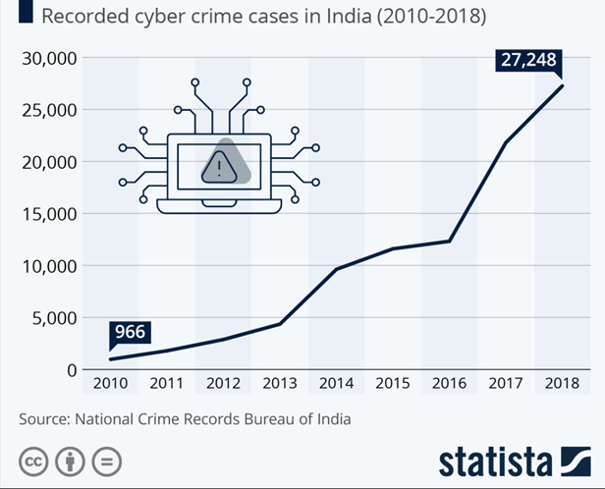

**Figure 2.2.4:** Rise observed in the number of cybercrimes in India

Online gaming contributes as a significant player in the seemingly unstoppable rise of cybercrimes. A full-proof security parameter is thus needed to ensure the safety of the user and his data. Research by Ying-Chieh Chen Et al. [3] elaborates on the widespread criminal activities propagated through gaming platforms. The study also describes prevention methods one may adopt to safeguard their data while thoroughly enjoying their time on gaming platforms and interactive interfaces.

In layman's terms, online gaming is a video game that allows players to engage and interact with each other using the internet as a medium to communicate. The online platform offers a multitude of gaming interfaces such as the single-player engine and the multiplayer engine, also known as the massive multiplayer online role-playing game (MMORPG), where multiple people interact and participate in computer entertainment.

The COVID-19 outbreak posed a serious threat to public health and the entertainment industry. Many individuals turned to home entertainment during periods of self-isolation while cinemas and theaters shuttered their doors to stop the spread of the disease. According to a survey conducted in March 2020, gamers in the United States spent 45 per cent more time playing video games during the quarantine than the previous week. The following **Graph 2.2.5** shows the statistics of the time spent by youngsters of different countries in gaming during the COVID-19 pandemic period.

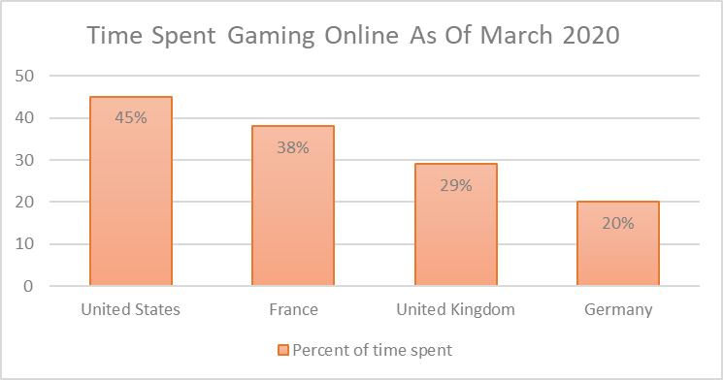

**Figure 2.2.5**: Statistics of the time spent by youngsters of different countries in gaming

As a ramification of the rise in online gaming, numerous real-world issues have emerged which have had a significant impact on our society. Before the onset of online gaming, all computer games were single-player, meaning they were against a single computer opponent. In online games, people compete against or collaborate with human players, thereby influencing them to such an extent that they gradually lose the ability to distinguish between real-life situations and computer-generated simulations.

Games played online via a LAN, the internet, or even telecommunication are known as online gaming. The term "browser-based game" or "web game" refers to a game played in a browser. The following **Figure2.2.6** describes the different types of online games.

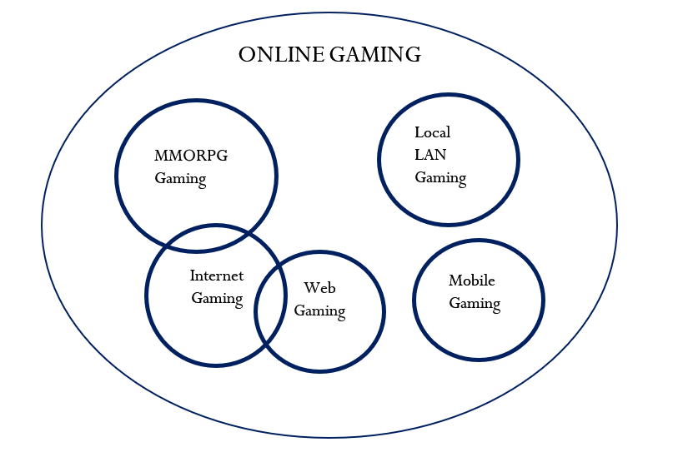

**Figure 2.2.6:** Different types of online games

How communities emerge in the real world, online gaming has also evolved into a strong and close virtual community because internet engagement is a crucial part of the gaming community.

In online gaming, gamers can form virtual friendships with other players who share the same goals and interests. The diversity, unity, and reciprocity evident among other players contribute to building a safe and dependable virtual community. However, the virtual world permits gamers to participate in acts they refrain from participating in the real world.

With the rise in popularity of online gaming, criminal issues and anti-social conduct are increasing gradually. At this point, it is best to think of online gaming crimes as a distinct type of cybercrime. The research paper: "Online Gaming Crime and Security Issue – Cases and Countermeasures from Taiwan" describes the growth of cybercrimes with online gaming as a platform by first describing the virtual environment and properties of any computer game. To afford upgrades and updates of virtual characters of any game, players often participate in mutual trade of assets as they do not have the required finances to afford the said upgrades on their own. To complete any online transaction related to in-game purchases, having a UserID becomes mandatory. The UserID or game ID is a unique number assigned to each player by the game. Through this UserID, a player makes their presence known to the game server and other players in the server. The concept of scarcely producing game-specific updates is a common phenomenon in the gaming industry. Game developers generate these updates in reduced quantities to keep the players invested in the game. These offers make a crucial contribution to the virtual property of any game and its virtual community.

The rarity of certain items turns them into a money-making asset in the real world. The most expensive purchase ever made for a game item was a planet named Calypso in the game "Entropia universe" designed by the Swedish software company MindArk. The SEE virtual worlds, an entertainment company, purchased the planet Calypso for a staggering $6,000,000. When virtual properties become valuable in the real world, online games are no longer just entertainment. The involvement of real money can easily lead to conflicts of profit and resulting criminal behaviors.

With the prosperity of online gaming, criminal problems and anti-social behaviors are also quickly developing. These illicit developments have raised concern among many people. Among the cases prosecuted, online cheating is the most significant criminal behavior. Since the UserID means everything owned by players in the virtual world, hackers have aimed at the UserID and password as they try their best to compromise them.

**Figure2.2.7** shows the distribution of the crime related to online gaming and the premeditated intentions behind the crime.

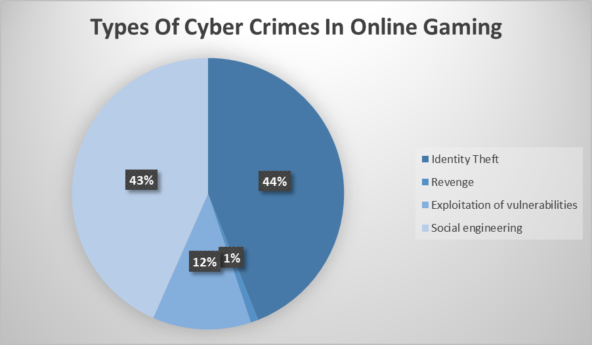

**Figure 2.2.7:** Types of Cybercrimes in online gaming

Identity theft is the most prominent of all cyber-attacks. To deploy a successful attack on a player and impersonate their online presence: hackers must have access to the players' UserID and password. The hacker follows some steps to infiltrate through the security precautions taken by the player. **Figure 2.2.8** describes the steps involved in the ordeal in detail.

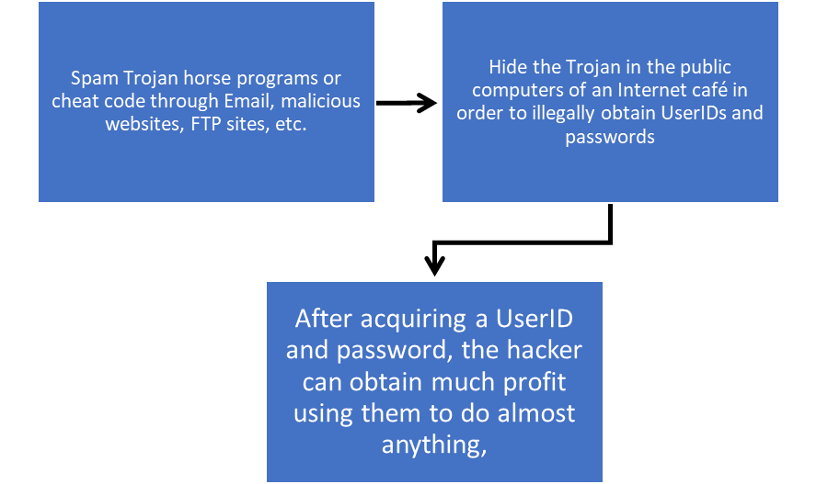

**Figure 2.2.8**: Steps involved to infiltrate through the security precautions

The above-mentioned threats continue to pose a threat to computer security and user privacy and identity. The research paper mentions that the best and most affordable method one may adopt to ensure the prevention of identity theft is through user authentication systems.

**Authentication mechanisms**

The best possible way to safely keep user data and prevent identity theft is to adopt full-proof and reliable authentication mechanisms. There are various categories of user authentication each differing in terms of the complexity of the security provided.

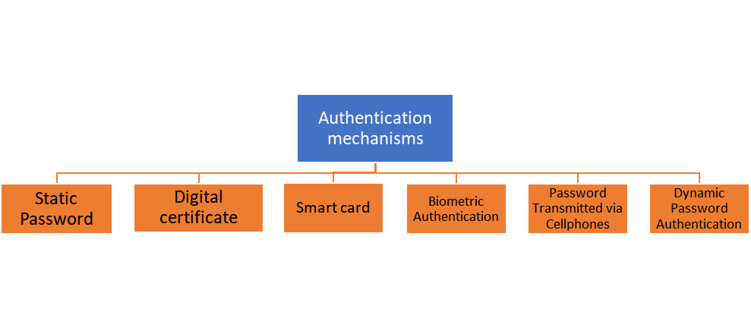**Figure 2.2.9:** Authentication mechanisms

1. **Static passwords**

* Simplest authentication mechanism
* Convenient for both players and the online gaming vendors
* The passwords in conjunction with the players’ UserID
* The UserID and passwords linked to this authentication are often vulnerable to Trojan attacks

2. **Digital certificates**

* A digital certificate is a tamper-proof set of data issued to verify a person's identity, a website's identity, or any other entity’s identity.
* The players must request a certificate from a reliable certification authority in advance which makes the process tedious and cumbersome.

3. **Smart Card**

* Also called an intelligent card
* Requires pre-installed card reading software and availability card readers
* The process of installing a card reader becomes complicated as most internet cafés do not have card reading facilities.

4. **Biometric Authentication**

* Includes fingerprint verification, hand geometry, iris scanning, retina scanning, voice recognition, signature verification or facial recognition.
* It is a very expensive ordeal to undertake for any individual player

5. **Password transmitted via cell phones**

* Due to the prevalence of cell phones, this authentication mechanism provides a feasible, effective, and secure scheme
* However, the cost consumption involved in this method makes it less practical and risky

6. **Dynamic Password Authentication**

* Includes One-Time Password (OTP) Authentication system
* The functioning is similar to a static password system as both UserID and password complement each other during the authentication process the only difference being that this conjecture is valid for only a single time use
* A small hand-held device, synchronizes with the target system's authentication scheme and displays a one-time password that periodically changes
* To access the target system, the user enters an assigned UserID and Password followed by the one-time password currently displayed on the hand-held device.
* This method of authentication provides high security, portability, and low cost
* The user must possess the UserID and password as well as the authentication one-time password

The difference between the six authentication mechanisms is depicted by **Table 2.2.4**. The differences are based on simplicity, mobility, security, ease of use, convenience, and cost.

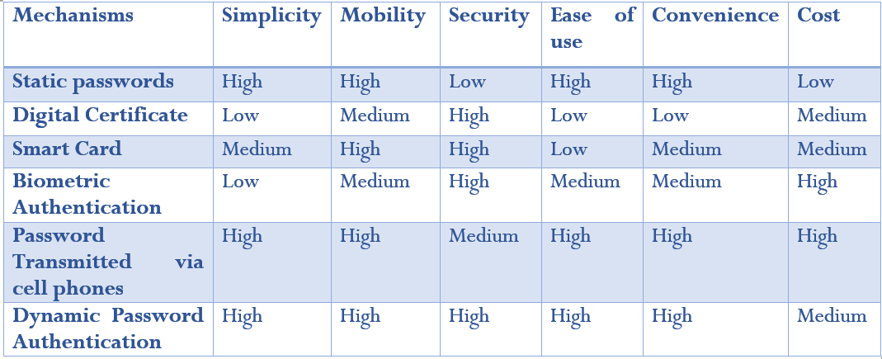

**Table 2.2.4:** Difference between the six authentication mechanisms

The paper by Borje Karlsson et. al [4] highlights the fact that the gameplay experience of networked games can be harmed by network security vulnerabilities and game exploits. This work aims to raise awareness of the issue among scholars by presenting: why study in this domain is important, the situation of existing research in the area, a classification of fraud types, and potential countermeasures through a large bibliography.

Networked games, whether multi-player or online in some other fashion, have experienced explosive growth in recent years. New network technologies such as wideband and wireless networks have also been introduced.

As a result, the amount of time and effort committed to the networking components of games has increased dramatically, yet few developers and researchers have considered security.

Another crucial element is that the player's interaction with a game is critical to its success. Communities form around games and are necessary to extend their life cycles; games are no longer just a product, but a service. And preserving this requires a safe and equitable environment. Due to these challenges, the focus shifted from single-user to multi-user games.

Section 2 presents a survey of research in networked games to explain where the latest work is concentrated, highlight certain security concerns in this type of environment, and demonstrate the importance of security in networked games.

Section 3 presents a classification of the most typical problems (including cheating) in the field of networked game security.

Section 4 briefly discusses some solutions for addressing these concerns, as well as relevant literature, research, and industry state-of-the-art efforts.

Section 2

This section provides an overview of changes in the field of online games, including changes in distribution schemes, patching, community development, the wireless market, more casual gamers (lesser diehard player fraction), and increased availability of network working middleware, and issues with online payment.

Section 3

This section categorizes types of attacks carried out on networked games into the following:

|  |  |
| --- | --- |
| **Attack** | **Description** |
| **Connivance** | When communication happens between two players that should not exchange secrets |
| **Policy abuse** | When a player makes use of the system policy to gain an advantage |
| **Virtual wealth** | Character or game item exchange, kind of real-life commerce created with the popularization of on-line games and that can be intentional or not. |
| **Service theft** | Non authorized usage of the system |
| **Event manipulation** | Consists in the cheater altering game events in order to gain an advantage |
| **Lack of secret** | The cheater has access to supposedly secret information that should not be available, can be accomplished by sniffing the network or by reading memory positions |
| **Internal misuse** | Bad faith from people within the organization responsible for the game operation |
| **Social engineering** | Usage of social engineering techniques in order to fool others into doing something that helps the cheater |
| **Rule manipulation** | Spoofing or authoritative clients, altering client software behavior or network information in order to circumvent game rules or to change a simulation result |
| **Bugs and design defects abuse** | Using breaches in the game implementation in order to obtain unfair advantages, like for instance, abusing dead reckoning and getting more time to react to an event |
| **Perfect game** | Utilization of bots, macros, or information collected outside the game world in order to accomplish a better performance |
| **Griefing** | Do not play the game, but use it as a medium to attack or disrupt other people's fun. |

**Table 2.2.5:** Categorizing the types of attacks

Section 4

The countermeasures for some of the attacks as listed in the study are as follows:

* Monitor strange behaviors in the game.
* Network performance monitoring for borderline conditions
* Automatic patching systems for fixing bugs
* Make players aware of security concerns
* Maintain an open and functional communication channel for complaints and audit game server logs.
* Software Security Tools like Anti-Cheat Software
* Usage of checksums to prevent reverse engineering of game protocol and network cheats.
* Encoding of every communication or instead of identifier use, pseudo-random numbers, or add a variable amount of padding to the packets in order to difficult their identification by size

The 2018 paper by Chen Zao Et al. [5] has investigated cyber security challenges in online games by providing background information and describing several prevalent cyber security threats, as well as giving a potential remedy. It also suggests future research directions for online game cyber security challenges in the hopes of giving practical solutions and beneficial information for game operators.

The common cybersecurity threats in games as mentioned in the paper are

1. Falsification of virtual goods or data

2. Hacking

3. Trojans

4. Man-made hacking

5. Server Maintenance Problem

The potential solutions for the same are as follows:

1. Well-built data encryption system

2. Advanced Identification Technology

3. Higher Performance Server or Bandwidth

The research directions suggested by the author for future studies on solutions for the cybersecurity issues in games include:

1. New and innovative authentication system to authenticate the legal identity of an entity as traditional network authentication has a number of security flaws. Due to the development of ever more significant network attacks, it is impossible to provide safe and dependable network services for players by using the centralized authentication technique.

2. New mathematical and cryptographic algorithms for the encryption-decryption system as recent studies show that the widely used MD5 algorithm is proven to show more and more vulnerabilities.

Towards the conclusion, the author writes that despite a slew of issues now plaguing online games, such as malicious tampering with virtual data, account theft, server maintenance, and so on, these issues are not insurmountable. To minimize some of the in-game information security difficulties and clean up the current game and network environment, a good data encryption system should be established with more advanced identification technologies and more advanced high-performance servers or broadband for game users and operators. Simultaneously, the advancement of many new fields, such as artificial intelligence, can help to create more stable and secure systems.

The 2020 paper on Security in Gaming by Dwip Makwana[6] highlights the fact that online games, especially multiplayer shooting games, require security because they are more popular than story mode games. Security in gaming, often known as cyber security in gaming, is a method of securing and preventing piracy in the gaming industry. It provides several options for safeguarding consumer game accounts. It includes a variety of effective techniques for both offline and online gaming platforms such as consoles, computers, and mobile phones. Gaming cyber security is progressing at a much faster rate than other security sectors. It also protects the player's in-game purchases and currency, which are traded between two players.

Gaming security is a vital consideration since the faster the gaming industry and technology improve, the more secure game accounts become.

Kerberos Authentication System used in gaming security framework is a type of authentication system in which whenever a user enters in to play games, the server verifies that they have entered the right credentials. The server then issues an authorization code to the user, that will be sent to the email or mobile information given when the account was established. Through the client application, the user can then access and play the purchased game. Figure **2.2.10** demonstrates this process.

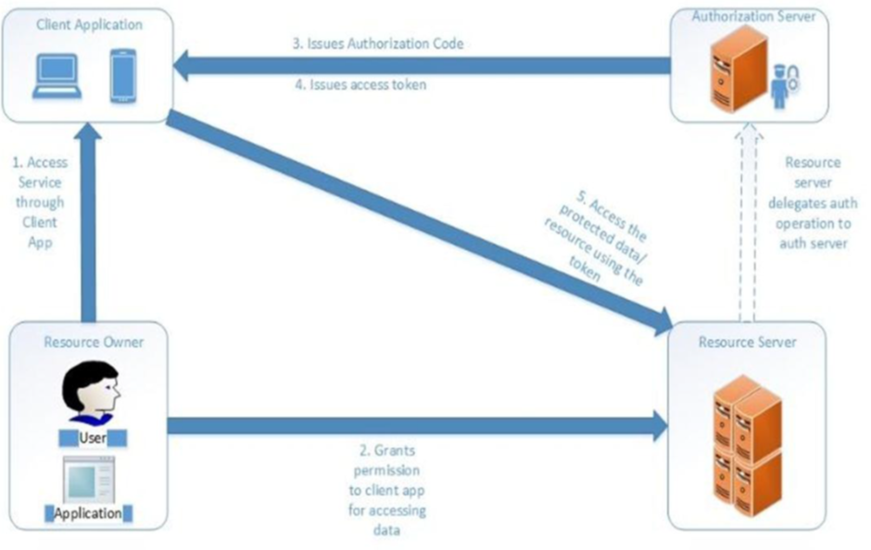

**Figure 2.2.10:** Kerberos Authentication System

Online gaming sessions often last between 10-15 minutes and are referred to as 'lobby’. These sessions may overlap or be established by malevolent users, resulting in bandwidth usage that exceeds available bandwidth. Malicious users' intrusion could result in a denial-of-service attack, causing the system to crash. Crashing frequently will cause dissatisfaction among the player community and a loss of the gaming company's image. Figure **2.2.11** depicts the threat of unneeded data flooding the lobby or server setup for multiplayer gaming.

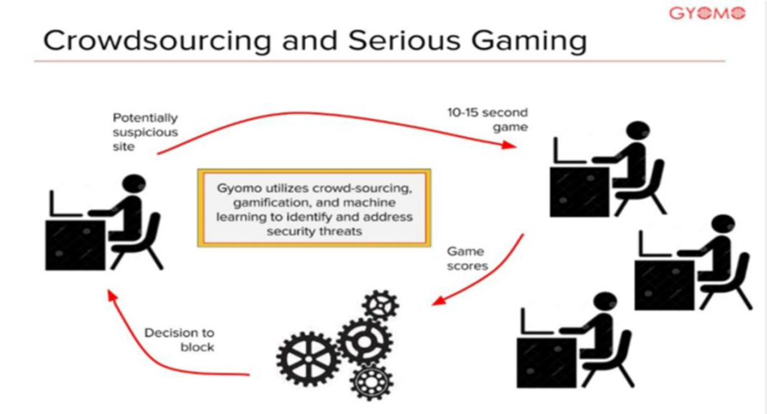

**Figure 2.2.11:** Threat of unneeded data flooding

PWC emphasizes two elements in particular for gaming security:

A. Connecting the player, Understanding the Risks, and Protecting Data. Experts define the future generation of players as tech-savvy and able to blend in-person and virtual activities more easily than ever before in connecting players.

B. Data security, they claimed that erecting a barrier around personal information is no longer a simple or totally secure solution, especially as the gaming industry works more to align services with a player-centric model.

This paper also enlightens the reader on a case study about Bethesda Studios' famed AAA blockbuster DOOM that was recently crashed and criticized when their latest game DOOM ETERNAL accidentally released a DRM-free version. Before the firm patched the games, players who relied on cracked games were able to get their hands on them. The crackers were so quick that they were able to rig a DRM-free version of the game within the game's folders and breach it. Even before the game company could patch and re-release it, the cracked version was widely circulated. Aside from this diatribe, Bethesda Studios has made a lot of money with DOOM ETERNAL since it has fewer micro transactions, making it a more balanced game against wealthier gamers.

In the conclusion, the author states that gaming companies can encrypt their files using their own, private encryption techniques to avoid being cracked in a short span of time after being released. Integrity poisoning is made more difficult by investing effort in encryption and generating new file extensions. By keeping source code security and delivering high-secured compression to the game files, MODS-supporting scripts can be avoided.

For a more effective sales market, the author suggests that game prices could be reduced slightly on the pretext that players will not be motivated to play unlicensed games and will have access to all of the game's features. Reduced costs, particularly in PC games, can have a significant impact on piracy. Users that purchase the legitimate game rather than pirated game accounts from the black market can receive DLCs [downloadable content/extended narrative] as free material.

A Dos attack is a cyber-attack that renders a host computer or device unavailable. A Dos attack uses a single device, while a DDoS attack or distributed denial of service attack uses multiple compromised devices to send traffic to a network. These attacks could be carried out by rival businesses or overly addicted fans who want to boost their ranks by harming other gamers. The research paper by Sanjana A et. al [7] discusses in great detail the impact of DDoS attacks on gaming servers and the threats it poses to the common user. Sometimes users engage in these attacks to express their anger toward content changes.

Based on several reports from multiple industries, online gaming industries are the number one target for DDoS attacks. Countries like Russia, Turkey, and the Netherlands have been known for the existence of gangs that perform DDoS attacks targeting mainly gaming servers.

The paper recounts some infamous incidents mentioned in the **table 2.2.6**

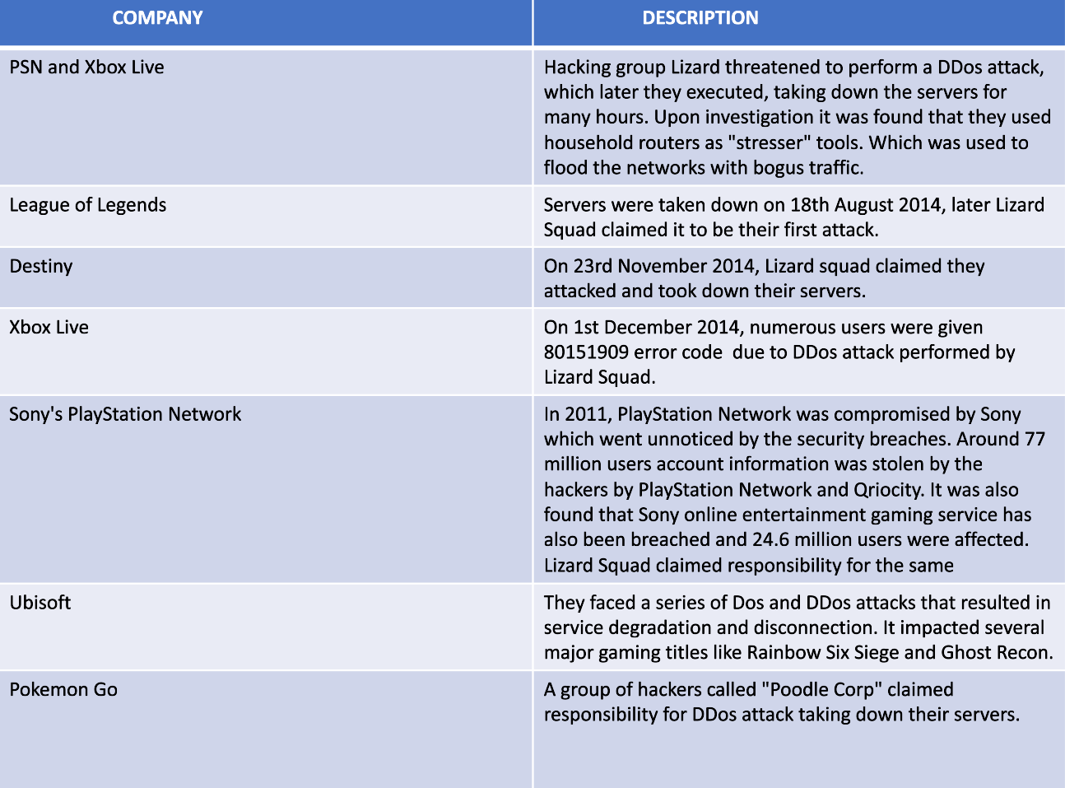

**Table 2.2.6:** Some infamous cyber attacks

There are several factors contributing to attacks in online gaming such as -

1. Business Competition
2. Extortion
3. Hacktivism
4. Vandalism
5. Nature of Gaming

The paper also gives an insight into certain loopholes and vulnerabilities -:

1. Predicting rush hours: DDoS attacks are most effective when the resources are already scarce. Hence, predicting and attacking when the number of users online is maximum will disrupt services faster due to already existing saturation.
2. Do not have to take it offline: DDoS attacks do not necessarily bring down the server but can also ruin the gaming experience.
3. Proprietary Protocols: For a gaming application it is not easy to distinguish between online gamers and a DDoS bot.
4. Single points of failure: Many games are managed from central platforms. When hackers take down these singular points it brings down the entire game.
5. UDP: User Defined Protocol is popular among DDoS attackers because it's easy to spoof and used in almost all DNS amplification attacks, which exploits the vulnerabilities and loopholes in the domain name system.

Some Control measures, talked about in the paper, which we can use to protect ourselves from DDoS attacks are -

* Anti-Malware Software: It will monitor the internet connection. It will use existing malware and bot signatures to identify and block them from infecting our computers.
* VPN: Virtual Private networks use protocols to encrypt the data and send it through servers between senders and receivers so that the data is not exposed.
* Generic Routing Encapsulation Tunnel: A GRE tunnel reduces the network traffic and establishes a high-speed point-to-point connection between the network nodes that will bypass normal routing disturbances.

The world of modern computers has been taken over by online games. Gaming has always been (and continues to be) the primary driver of PC technology, with a large consumer market. It has risen at the same rate as the Internet over the last ten years, and can now be found in tens of millions of systems. Research by Gary McGraw et. al [8] explores the dark side of online gaming servers and the threats that are posed to the gamers communicating on the platforms. With the Internet's spectacular expansion comes a slew of adolescent growing pains, the majority of which concern troublesome and widespread computer security vulnerabilities. Online games, particularly massively multiplayer online role-playing games (MMORPGs), are directly affected by such security issues; MMORPGs include World of Warcraft, Second Life, Everquest, EVE Online, Star Wars Galaxy, Lineage, Ultima Online, etc.

**Massively Distributed Systems**

Online games are notable in terms of attack patterns because of their architectures and the security challenges that come from them. MMORPGs are developed from extremely complex software that are deployed over a large number of servers. (Here "huge," means over 400,000 fat clients simultaneously linked to banks of central servers running the complicated gaming software.) These games are particularly fascinating as a case study in software security since they push the boundaries of software technology, notably in terms of state and time. MMORPGs, in reality, are a forerunner of future technological software security challenges.

Modern software is becoming increasingly dispersed, with servers interacting with thousands of users at once. Following closely after online gaming is the shift to Web services and service-oriented architecture (SOA) created using technologies such as Ajax and Ruby.

The fact that online games are major money just adds to the severity of the security challenge. Criminals congregate and remain wherever money is involved. Cheaters in MMORPGs have a financial motive to violate the games' security and earn virtual stuff or experience points for their characters. After then, many of these objects, including the characters themselves, are auctioned to the highest bidder. For years, sophisticated hackers have labored in the fruitful fields of MMORPGs, with some making a living solely from gaming (or cheating at gaming).

**Time & State Bugs**

System heavy games, by their very nature, need a massive quantity of data storage spread across several servers. Some servers keep track of financial information, while others keep track of player statistics and inventories. The most significant issues arise when state data is "cracked" and sent to untrustworthy gaming clients. The dangers of using a 'rogue game client' have been ignored by most game creators. As a result, certain state manipulation attacks can be as straightforward as altering the game client software's settings.

**Tele hacking: A Simple State Manipulation Attack**

All the 3D object interactions and the state machine that regulates travel, are stored in the client program. A player may change how he/she travels by changing the client. As a result of this, a lot of typical game vulnerabilities change how the client software handles travel. Finding and resetting the player character coordinates in an online game is a simple and elegant example of state manipulation. Tele hacking uses a player's character location setting for teleporting across large areas of the game world, rather than minor teleports to the proper position within a few virtual yards. This exploit finds its use in MMORPG’s.

**Using bugs to confuse state boundaries**

Telehacking in World of Warcraft is a simple example of state manipulation, but time and state problems can be far more complicated. Timing issues abound in many software state boundaries. Finally, the most fundamental issue is 'trust'. If the client software is trusted to change state correctly while also being under the control of a possible attacker, security issues will arise.

Online games such as MMORPG's have been steadily developing from a social, economic and cultural perspective. Massive multiplayer games such as World of Warcraft have been influencing the lives of both competitive and casual players. The videogames business generates stunning revenues of approximately $30 billion per annum worldwide (according to the Entertainment Software Association (ESA). The research paper compiled by Jiankun Hu et. al [9] elaborates the risks involved in MMORPGs and the types of cheating people indulge in while participating in online gaming. The current sales of game-related merchandise in the United States alone are around $230 million.

MMOGs have two characteristics:

1. In these games, players compete against one another via game client software distributed among individual players connected via various networks.

2. It is difficult to determine whether an action response received at the game server is initiated according to the game's rules or not.

As a result of these qualities, MMOGs are prone to attacks like collusion and game procedure abuse.

Cheating in MMOGs is caused due to traditional security breaches, in which the only properties in question are confidentiality, integrity, and availability. MMOG cheating, on the other hand, has its own set of characteristics, such as social behavior not seen in traditional security scenarios. As a result, it is critical to comprehend these unique security concerns and innovative anti-cheating solutions with both theoretical and practical approaches.

**Classification of Cheating Techniques**

A Framework for the Classification of Cheating in MMOGs was given by Yan and Randell that classifies cheating in games into two broad categories.

**Cheating Techniques**

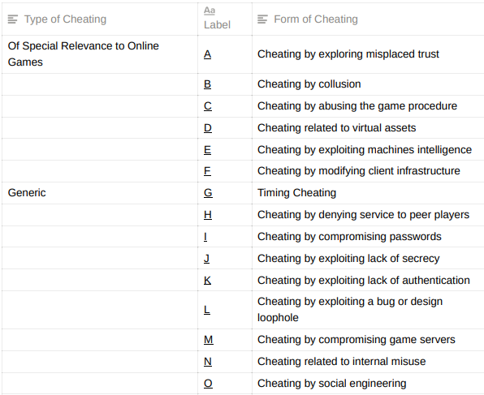

**Table 2.2.7 :**Cheating Techniques

**Security Tree for MMOGs**

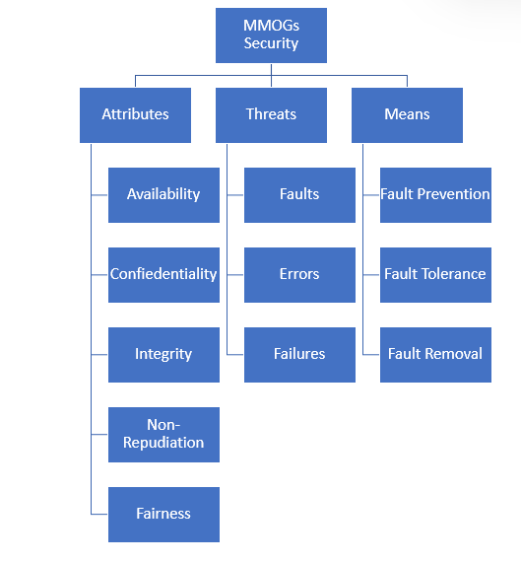

**Figure 2.2.12:** Security Tree for MMOG

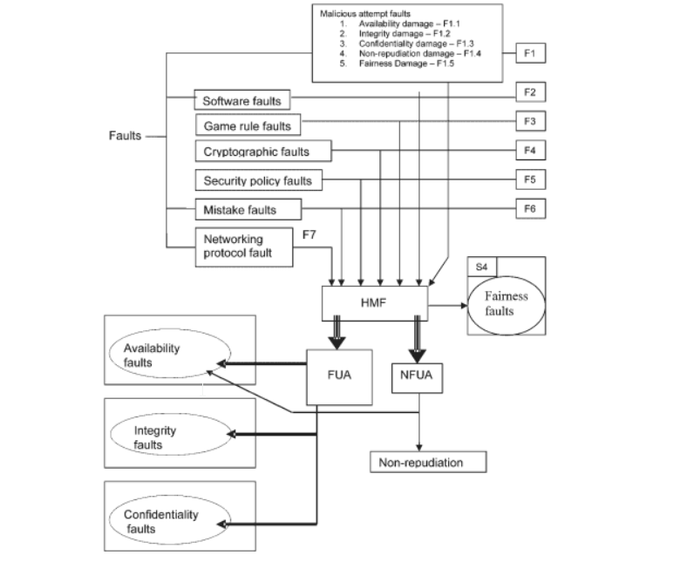

**Figure 2.2.13:** Representation of different types of cheating

Cheating by Exploiting Trust: On the client-side, this trick typically entails tampering with game code, configuration data, or both. If we consider the game client code and configuration data to be an intrinsic part of the MMOGs system, we can ascribe this cheating to integrity faults generated by a mix of malicious attempt errors F1.2 and software faults F2.

Collusion Cheating: In the event of 'win-trading' cheating, it can be represented as a fairness fault created by the combination of a malicious attempt fault F1.5 and a game rule fault F3. Collusion cheating in contract bridge is a fairness fault created by a combination of the malicious attempt fault with the goal of confidentiality damage F1.3 and the collusion cheating fault.

Cheating by Abusing the Game Procedure: The escape cheating by disconnecting is a fairness fault created by the combination of the malicious attempt fault with the goal of fairness damage F1.5 and the game rule fault F3. The availability problem is an intermediate defect.

Cheating with Virtual Assets: Cheating with virtual assets can be classified as a non-repudiation fault generated by the malicious attempt fault with the goal of non-repudiation damage F1.4 and the security policy fault F5.

Cheating by Exploiting Machine Intelligence: cheating by employing an external computer program to assist gaming is a fairness fault created by a combination of the malicious attempt fault with the goal of fairness harm F1.5 and the game rule fault. F3.

Cheating by Modifying Client Infrastructure: The 'wall hack' cheating can be considered a fairness fault generated by a combination of the malicious attempt fault with the goal of fairness damage F1.5 and the software fault F2. F1.2 can also be used for confidentiality damage.

Denying Service to Peer Players: This is comparable to the general availability fault, which can be created by a combination of the malicious attempt fault with the goal of causing availability harm F1.1 and a game rule fault. F3.

Timing Cheating: suppress-correct cheating by dropping update messages at the 'proper' moment is a fairness fault caused by a combination of the malicious attempt fault with the goal of fairness harm F1.5 and game rule fault. F3. Password Cheating: This is a confidentiality flaw produced by the malicious attempt fault F1.3 and the security policy fault F5.

Cheating by Compromising Passwords: This is a security policy fault created by the malicious attempt fault with the goal of causing confidentiality damage F1.3 and security fault F5.

Cheating by Exploiting a Lack of Secrecy: this is a security policy fault caused by the malicious attempt fault with the goal of causing confidentiality damage F1.3. F5.

Cheating by Exploiting Lack of Authentication: This is a fairness fault generated by the malicious attempt fault F1.5 and the security policy fault F5.

Cheating by Taking Advantage of a Bug or Loophole: This is a fairness flaw caused by the malicious attempt fault with the goal of causing fairness damage F1.5 and the security policy fault F5 or game rule violation, F3.

Cheating by Hacking a Game Server: This is an integrity fault created by a malicious effort fault with the goal of causing integrity damage F1.2 and a software fault, F2.

Internet Misuse Cheating: This is a fairness fault created by the malicious attempt fault with the goal of non-repudiation damage F1.4 or fairness damage F1.5. Also, the security policy fault, F5.

Cheating via Social Engineering: This is a confidentiality flaw induced by the malicious attempt fault F1.3 and the security policy fault F5.

|  |  |  |  |
| --- | --- | --- | --- |
| **Article** | **Paper outline** | **Discussions** | **Countermeasures** |
| [1] | Research paper on the increasing number of threats due to monetization of online games. | * Synopsis of technological risks involved in real money being exchanged in virtual communities. * Social risks involved in unregulated monetary exchanges among online communities. * Gaming specific mitigation techniques and practices. | * Use of Antivirus, Antispyware and Firewall programs. * Creating and using strong passwords. * Constantly updating and patching applications. * Verifying the authenticity and security of downloaded files. * Identify and backup personal and file data. |
| [2] | Research paper discussing major threats involved in online games and the threat specific countermeasures that can be adopted to minimize the impact of an attack on a system. | * Enhance countermeasures against these illicit behaviors in online games, a thorough understanding of current industry preventive approaches and current state-of-the-art research efforts. * The severity of the after effects that are observed on client systems and game provider servers. | * Client-side: Install bot detection programs. * Network-side: Protect network traffic. * Server-side: Data mining and analysis to find out game bots' play patterns. * Client-side: Install game security solutions. * Server-side: Implement investigation code that inspects all incoming packets. * Installation of bot detection programs. * Implement a private server detection module. * Enforce system and network security. * Enforce individual PC security or provide multi-factor authentication * Enforce in-game monitoring by game masters (GMs). |
| [3] | Detailed overview on the widespread criminal activities propagated through gaming platforms and provide prevention methods one may adopt to safeguard their online data. | * Statistics of the time spent by youngsters of different countries in gaming * Different types of online games * Types of Cybercrimes in online gaming * Steps involved to infiltrate through the security precautions * Various Authentication mechanisms * Difference between the six authentication mechanisms | * Static passwords * Digital certificates * Smart Card * Biometric Authentication * Password transmitted via cell phones * Dynamic Password Authentication |
| [4] | Paper highlights the vulnerabilities that arise in the network aspect of online games and how the exploitation of these vulnerabilities can risk the security of users. | * Highlights include the amount of time and effort committed to the networking components of games has increased dramatically and how only a handful of developers and researchers have considered security. * a survey of research in networked games to explain where the latest work is concentrated, highlight certain security concerns in this type of environment, and demonstrate the importance of security in networked games. * A survey of research in networked games to explain where the latest work is concentrated, highlight certain security concerns in this type of environment, and demonstrate the importance of security in networked games. * Classification of the most typical problems (including cheating) in the field of networked game security * Various attacks and exploitations of threats with description of each attack | * Monitor strange behaviors in the game. * Network performance monitoring for borderline conditions * Automatic patching systems for fixing bugs * Make players aware of security concerns * Maintain an open and functional communication channel for complaints and audit game server logs. * Software Security Tools like Anti-Cheat Software * Usage of checksums to prevent reverse engineering of game protocol and network cheats. * Encoding of every communication or instead of identifier use, pseudo-random numbers, or add a variable amount of padding to the packets in order to difficult their identification by size |
| [5] | Paper investigates cyber security challenges in online games by providing background information and describing several prevalent cyber security threats, as well as giving a potential remedy. | * Future research directions for online game cyber security challenges in the hopes of giving practical solutions and beneficial information for game operators. * Common cybersecurity threats in games. * Potential solutions * Research directions suggested by the author for future studies on solutions for the cybersecurity issues in games | * Well-built data encryption system * Advanced Identification Technology * Higher Performance Server or Bandwidth * New and innovative authentication system to authenticate the legal identity of an entity as traditional network authentication has a number of security flaws. * New mathematical and cryptographic algorithms for the encryption-decryption system. |
| [6] | Research paper discusses the importance and need of tamper-proof security of multiplayer games and highlights the existing authentication systems that envelope the security of multiplayer games. | * Gaming security and the need for its vital consideration into online MMORPGs. * Detailed workings of the Kerberos authentication system * Threat of unneeded data flooding the lobby or server setup for multiplayer gaming. * enlightens the reader on a case study about Bethesda Studios' famed AAA blockbuster DOOM that was recently crashed and criticized when their latest game DOOM ETERNAL accidentally released a DRM-free version | * Connecting the player, Understanding the Risks, and Protecting Data. Experts define the future generation of players as tech-savvy and able to blend in-person and virtual activities more easily than ever before in connecting players. * Data security, they claimed that erecting a barrier around personal information is no longer a simple or totally secure solution, especially as the gaming industry works more to align services with a player-centric model. |
| [7] | Paper discusses in great detail the impact of DDoS attacks on gaming servers and the threats it poses to the common user. | * Paper recounts some infamous incidents, the victim organization and the description of the attack. * Several factors contributing to attacks in online gaming are mentioned. * insight into existent loopholes and vulnerabilities | * Anti-Malware Software: It will monitor the internet connection. It will use existing malware and bot signatures to identify and block them from infecting our computers. * VPN: Virtual Private networks use protocols to encrypt the data and send it through servers between senders and receivers so that the data is not exposed. * Generic Routing Encapsulation Tunnel: A GRE tunnel reduces the network traffic and establishes a high-speed point-to-point connection between the network nodes that will bypass normal routing disturbances. |
| [8] | The research paper explores the dark side of online gaming servers and the threats that are posed to the gamers communicating on the platforms. | * Discussions on Massively Distributed Systems * Online games are major money adds to the severity of the security challenge * Cheaters in MMORPGs have a financial motive to violate the games' security and earn virtual stuff or experience points for their characters * Description of Time & State Bugs * Tele hacking: A Simple State Manipulation Attack * Using bugs to confuse state boundaries | Authoritative and mirrored server designSoftware obfuscationPlayer supervisionAnomaly detection  * sandboxing can effectively prevent the underlying cheat mechanisms from working, and thereby can avoid the need for banning game community members |
| [9] | Paper elaborates the risks involved in MMORPGs and the types of cheating people indulge in while participating in online gaming. | * Characteristics of MMOGs: players compete against one another via game client software distributed among individual players connected via various networks and difficult to determine whether an action response received at the game server is initiated according to the game's rules or not. * Classification of Cheating Techniques * Security Tree for MMOG * Representation of different types of cheating * Timing Cheating * Cheating by Compromising Passwords * Cheating by Exploiting a Lack of Secrecy * Cheating by Exploiting Lack of Authentication * Cheating by Taking Advantage of a Bug or Loophole * Cheating by Hacking a Game Server * Internet Misuse Cheating * Cheating via Social Engineering | Banning playersSuspensionIn-game kick  * Installing anti-cheat systems  DemotionProgress-removal |

**Table 2.2.8:** Summary of literature reviews

**CHAPTER - 3**

**DESIGN METHODOLOGY AND ITS NOVELTY**

**3.1 INTRODUCTION**

The rate of occurrence of cyber-attacks on online gaming servers and platforms has continued to grow at a startling rate preying on innocent players and delivering financial damage to victim organizations. The most prominent attacks that continue to wreak havoc are those of DDoS attacks and identity theft with a never-ending list of victims.

To understand the working of a cyber-attack that spread through MMORPG platforms, our team decided to implement a few of the most prominent threats and attacks, scaling them down to a minuscule degree to gain a better insight into the mode of propagation and extent of damage caused by the attacks.

These miniature simulations will help highlight the vulnerabilities of any server or system and provide us with potential solutions and mitigation strategies to be adopted to prevent such attacks.

**3.2 IMPLEMENTATION TECHNIQUES**

**3.2.1 DoS ATTACK**

A Denial-of-Service (DoS) attack is one that attempts to bring a machine or network to a halt, rendering it unreachable to its intended users. DoS attacks work by flooding the target with traffic or transmitting information that causes it to crash. This attack was used in holding the in-game lobbies hostage and ruined the experience of players in 'Apex Legends'. Where the attacker would DoS the server and forge the game results according to his will.   
**Procedure:** We used a dummy website (www.certifiedhacker.com) as a target for our experimentation. For Dos attacking the website, we used a Dos tool known as HULK - v3. Wireshark was used for analyzing the packets being sent by HULK -v3. After sending an enormous amount of packets to the website we observed the website started lagging & basic functionalities stopped responding.



**Figure 3.2.1.1** Dummy website

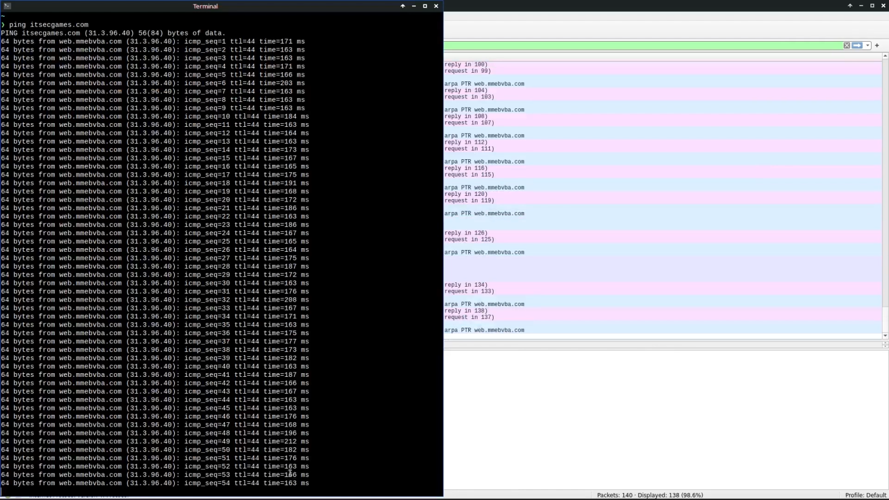

**Figure 3.2.1.2** Performing attack using HULK

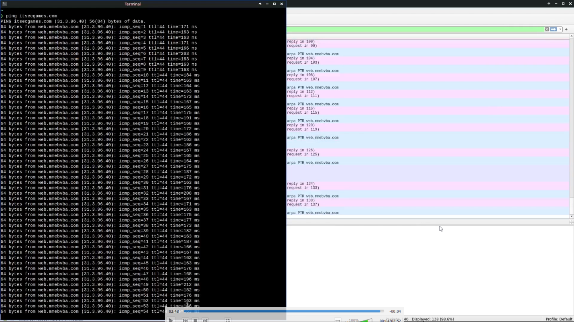

**Figure 3.2.1.3** Analyzing packets using Wireshark

**3.2.2 CLIPBOARD HIJACKING**

An attack that copies a URL to a computer's clipboard is called clipboard hijacking. It is generally impossible to erase clipboard data unless a computer is rebooted, which is the monopoly of this attack tactic. Clipboard hijacking is simple to execute yet a dangerous one. This is because the clipboard usually contains sensitive data such as usernames, passwords and credit card numbers etc., that can be easily extracted & misused. The harmful material in the clipboard is a seemingly harmless link to a redirected website. That website promotes a spyware tool masquerading as anti-virus software. The insidious element of this assault is that this URL is accidentally pasted from the clipboard along with any other text, so people unknowingly disseminate it by pasting it in their email, blog posts and comments, documents, and other places where the text is pasted.

**Procedure:** We made a sample .txt file. The modules we used were win32clipboard and smtplib. The module win32clipboard is the inbuilt module in python to retrieve the clipboard data. The module smtplib (Simple Mail Transfer Protocol) is communication protocol so that the clipboard we want to access can be brought out through mail. Then, we set parameters of which name and directory .txt file should be opened in order to write the copied data. Later, we set overall mail structure by passing details about in which form the data will be written, to which email data will be sent to retrieve it and whether sending it as an attachment or something else. We checked the inbox of the email stated for receiving the data. Then we opened the attachment named “data.txt” to see what is the clipboard data. Finally we verify that the data that we copied in our notepad is extracted.

The code used to perform the minuscule version of the clipboard hijacking attack is provided in **Figure 3.2.2.1**  and **Figure 3.2.2.2**:

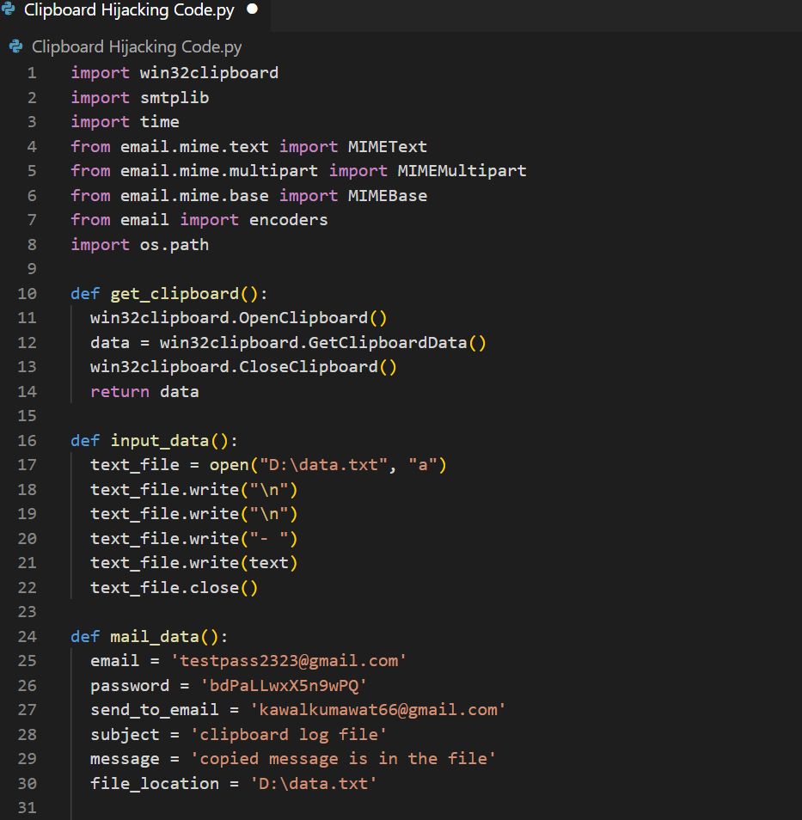**Figure 3.2.2.1** Code snippet 1

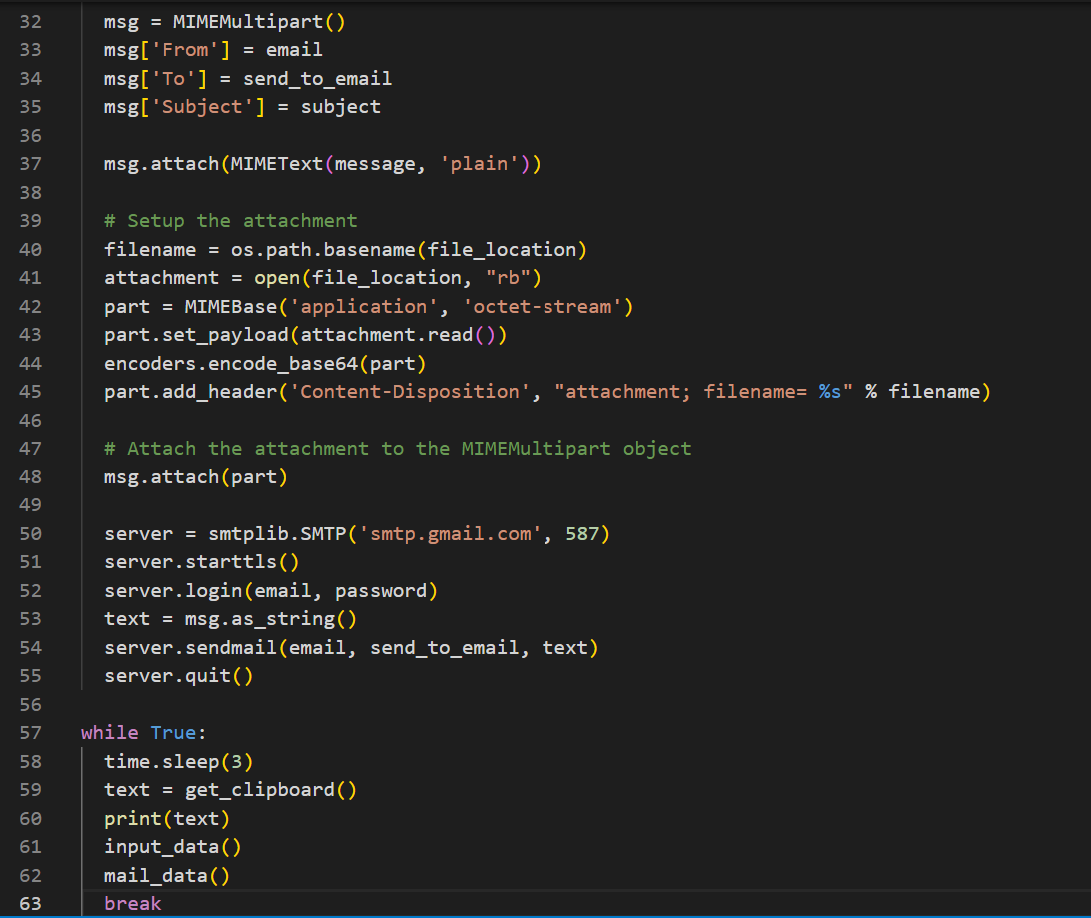

**Figure 3.2.2.2** Code snippet 2

## **CHAPTER- 4**

## **TECHNICAL IMPLEMENTATION & ANALYSIS**

**4.1 INTRODUCTION**

Case studies give us a range of perspectives, giving us an opportunity to gain deeper understanding into our topic. The in-depth investigation and analysis of these real-world occurrences provide a deeper insight on the need for awareness surrounding Cyber-security in games and how we can prevent a vicious scale attack on computer systems to ensure uncompromised user privacy and data security.

#### **4.2 CASE STUDIES**

Under this section of the research paper the team elaborates on the recent case studies which impacted organizations and individuals due to its dangerous and infectious nature resulting in compromised security of essential data and services.

#### 

#### **4.2.1: CASE STUDY 1 – Ransomware Attack**

Ransomware attacks are affecting every industry out there. Video games are also being affected by this malicious attack, prompting them to step up their defenses. The threat is not only to the data of users and programmers but also to the source codes and game prototypes.

[12] Capcom is a Japanese video game developer and publisher. They have created many popular franchises like Resident Evil, Monster Hunter, and Dead rising. In November 2020, it faced a Ransomware attack that forced them to shut down portions of its network. It was Raganar Locker Ransomware that stole sensitive information and locked the system.

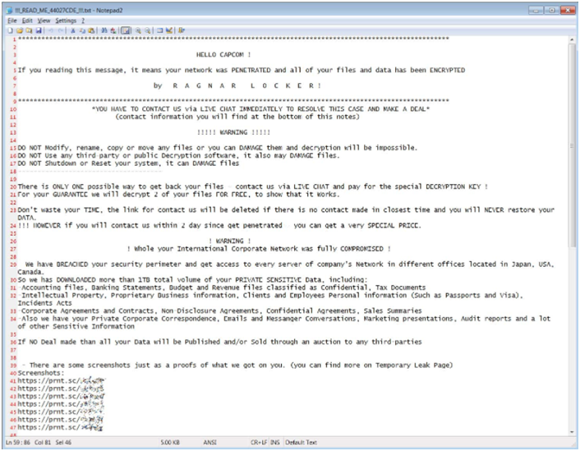

**Figure 4.2.1.1: [12]** Message shown by Ragnar Locker in a compromised device

[13] An investigation of the incident revealed an old VPN backup device located at the company’s North American subsidiary in California, which the attackers used to gain access to the internal network. From here onwards, it spread to other systems belonging to different offices. On November 1st, it released its file-encryption malware.

Capcom released a statement saying they were in the process of updating all their devices and boosting defenses, but due to the pandemic and the start of remote work, they kept the VPN device as a backup. According to investigations, they were affected at the wrong time.

Less attention was being paid to cybersecurity as they were trying to adapt to the pandemic. They decided not to pay the ransom leading to the leak of information.

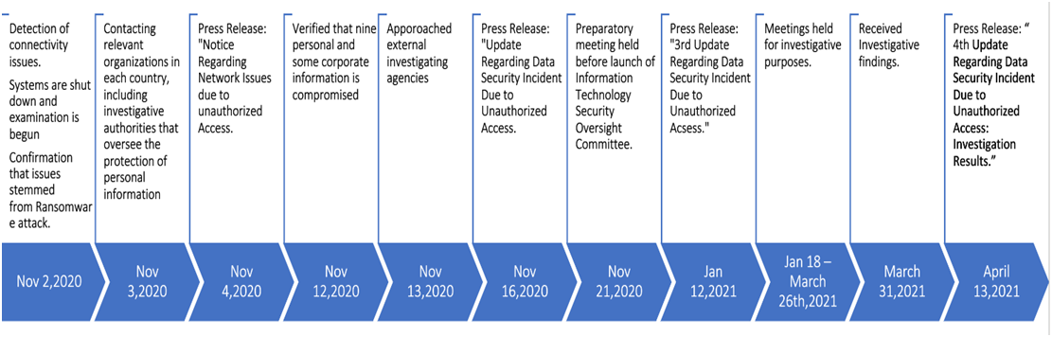

**Figure 4.2.1.2:** Timeline of the attack

[14] They took several measures to increase their defenses -:

1. They began by removing all compromised devices and reverifying the safety of all VPN devices.
2. Introduction of Security operation Center to monitor external connections
3. Adopted Endpoint Detection and Response for early detection of unusual activity.
4. Strengthened their organizational processes.
5. Supported those affected by the incident.

The Capcom ransomware incident taught us to give cybersecurity priority at all times. No matter which situation we are facing, it is necessary to keep security as one of the primary issues to address.

#### **4.2.2: CASE STUDY 2 – DDoS Attack**

**Case Study 4.2.2.1:**

Apex is a free-to-play shooter game developed by Respawn Entertainment. Released in March 2021 on Microsoft Windows, PlayStation 4, Xbox One, and Nintendo Switch, it is a highly competitive multiplayer game where players actively invest their time and money to rise above the ranks and make their place on the leaderboard. Ever since their game launched, they started experiencing Ddos attacks which only increased over time.

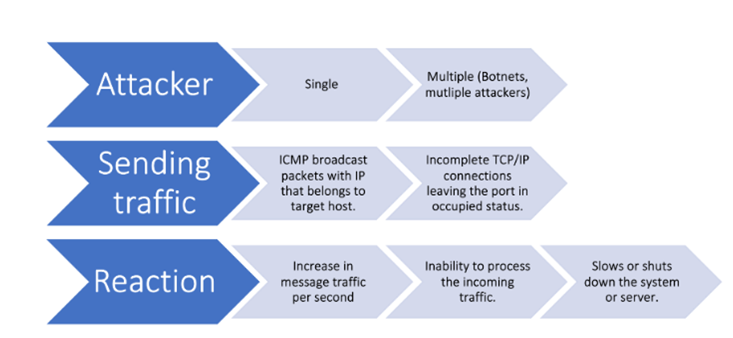

**Figure 4.2.2.1.1:** Steps in a Ddos attack

DDoS attacks or Distributed Denial of service attacks occur when a malicious individual or a group of people intentionally targets a server and sends heavy traffic to slow or even take it down. These attacks are very destructive as it disrupts the gaming experience completely. The malicious actors win games unethically, as the others players who are participants in the match, become slow or exit entirely.

[15] The participants lose their points which they call ranked points or RP. These attacks also seem to attack streamers specifically. A streamer called TSMFTX ImperialHal faced severe attacks while streaming his Apex legends game-play where he could not even exit the game by killing himself. His player was frozen in place, forcing him to take penalty points. He even tweeted about this where he posted the video showing this incident.

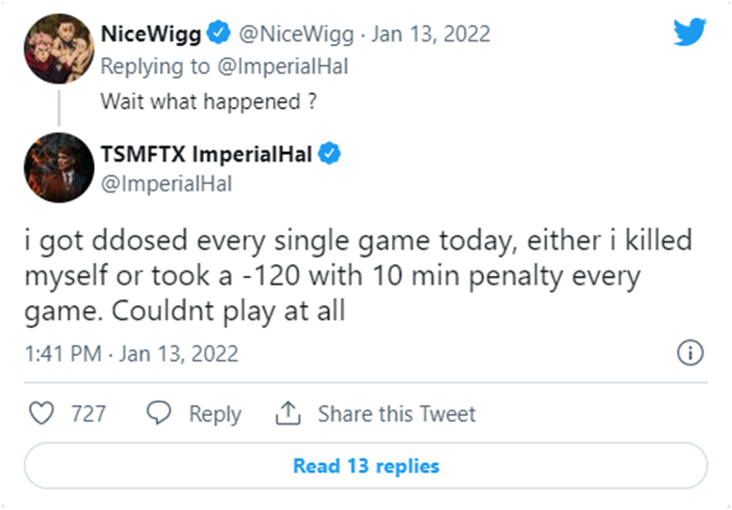

**Figure 4.2.2.1.2: [15]** Streamers tweet about the issues faced

[16] In an update, the developers handled these ddos attacks in a way that nobody expected. They released a statement saying, “Now when we detect an attack, all players will be removed from the game and granted loss forgiveness. The idea is to deny advantages to attackers and protect victims of those attacks from RP losses.” Meaning that whenever a ddos attack occurs in a particular contest, all the real players involved will be booted and removed. There will be no RP loss or gain, and neither will it reflect in the leaderboard disabling the attackers from gaining anything.

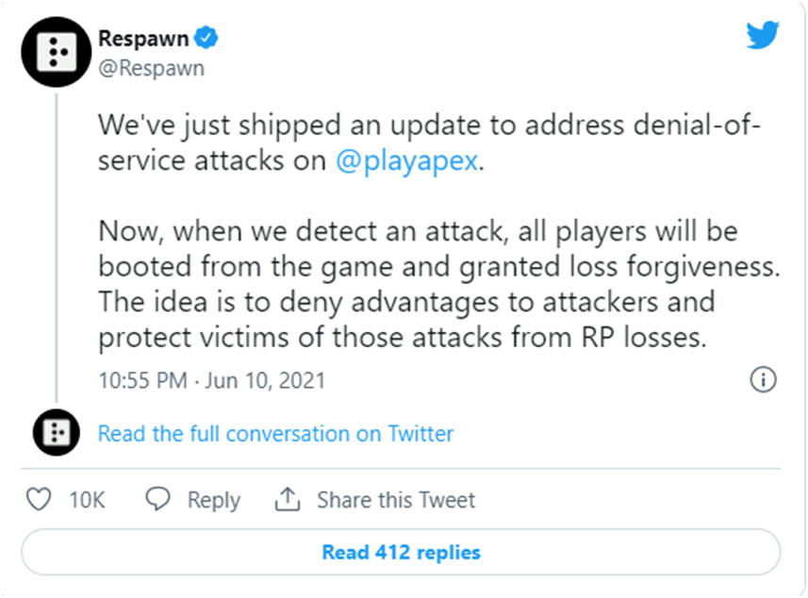

**Figure 4.2.2.1.3: [16]** Tweet about the updates in games by Respawn entertainment

DDoS attacks have become a popular hack to win games.Riot Games, a company behind popular games like League of legends and Valorant, has also experienced such attacks. Riot Games’ League of Legends tech lead Brian Bossé revealed on Twitter that they were experiencing a ddos attack in the clash mode of their game. Clash mode allows people to create teams with five people and compete in casual tournaments for winning goodies. Players started reporting issues where they were unable to log in. The game developers had to cancel the matches and refund their tickets. The reason was ddos attack.

**Case Study 4.2.2.2:**

The COVID-19 pandemic has triggered a series of large-scale cyber-attacks on various online recreational platforms, the most affected victim being the online gaming servers. From DDoS attacks to the spread of malware from the server to the users' computer systems, the gaming platform has seen all forms of security breaches in the past decade. Online gaming servers have indeed been a victim of various cyber-attacks, but the intensity of recent attacks has raised concerns from gamers worldwide.

A massive cyberattack on a significant Minecraft tournament brought Andorra's internet down. When hackers targeted the event, the European microstate, which is bordered to the north by France and to the south by Spain, experienced an internet outage, resulting in Team Andorra's elimination. Minecraft is a sandbox video game developed by Mojang Studios and Markus "Notch" Person in the Java programming language.

A sandbox game is a video game with a game-play feature that allows the player to interact with the game with a high degree of creativity, either without a stated aim or with one that the player determines for themself. Non-games or software toys are terms used to describe such games.

The particular cyber-attack in question victimized the participants of a Minecraft tournament that aimed to recreate the thrill and experience of the popular Netflix series Squid game.

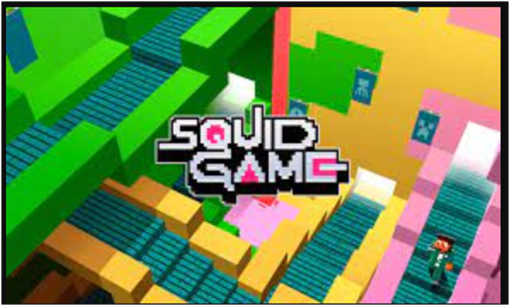

**Figure 4.2.2.2.1 :[27]**Squid Game

Andorra is home to a large number of the 150 SquidCraft game participants. Day one of the event, according to Spanish language reports, went off without a hitch for all players in terms of fairness. The games "green light, red light," and "hide and seek" went as planned. A programming error forced the "cookie game" to be halted on day two. After that, the DDoS attack on Andorra Telecom began, and eight or more of the principality's remaining players' connections and Twitch streaming were all taken down at the same time. Unfortunately, for more than half an hour after the DDoS attacks began, Andorra had minimal or no internet connectivity.



**Figure 4.2.2.2.2 :[26]**Map showing Andorra

Andorra Telecom tweeted an hour after the DDoS attack that created the above Twitch tournament disaster for the streamers that things were returning back to normal. The angry SquidCraft Games players could only speculate on the reasons for their disconnects till that moment. The Andorran contingent returned the next day of the event, but another DDoS on Andorra Telecom prompted the ISP to issue an irritated Tweet.

The Twitch competition eliminated all of the Andorran competitors in the SquidCraft Games.

**Graph 4.2.2.1.3** shows the internet connectivity and the fluctuations that were caused during the time of the DDoS attacks

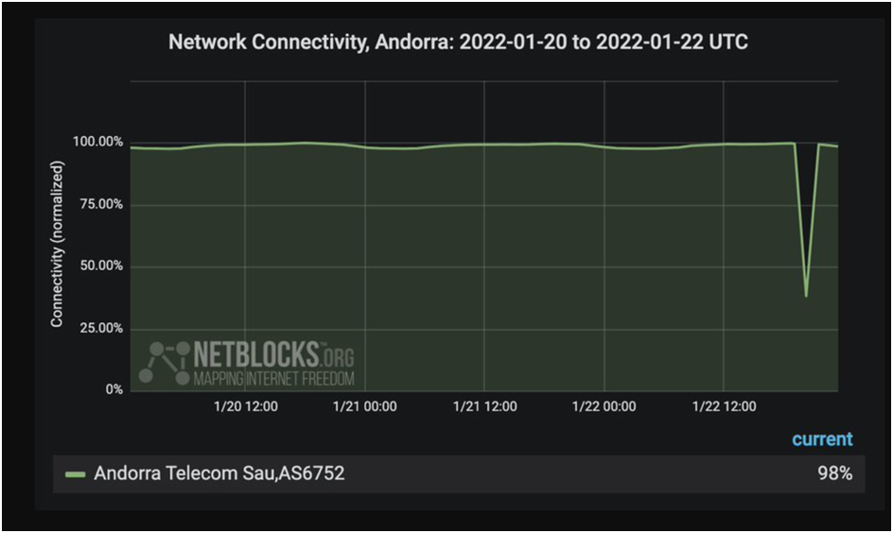

**Figure 4.2.2.2.3: [25]**Internet connectivity and the fluctuations

This attack stirred the participants and the viewers as they realized the impact of a full-scale cyberattack and the repercussions that a community may have to face as they try to successfully tackle the rising information security concerns in online gaming.

**4.2.3: CASE STUDY 3 - DATA BREACH**

[19] In April 2020, Nintendo was involved in a cyber-security controversy. It claimed that 160,000 accounts were compromised, but later upon investigation, they found that 140,000 more were affected. Out of the 300,000 affected accounts, only 1% were used in fraudulent activities.

The hackers infiltrated Nintendo's systems through a legacy system called the Nintendo Network ID (NNID). Players used NNIDs to access online content on the Wii U and 3DS now-discontinued consoles. NNID systems are still supported to allow older players to log into newer consoles the same way. The Nintendo data breach included the account owner's full name, email address, Date of Birth, and country of residence. The billing information was hidden, but users with linked accounts experienced suspicious activities, leading to the realization of a possibility of a data breach.

Although Nintendo did not disclose how hackers stole information, they confirmed it was not a breach in their servers. In a statement released, they said: *"obtained illegally from other than our service by some other means."*  There are three possible scenarios through which the hackers might have gained access shown in the table below -:

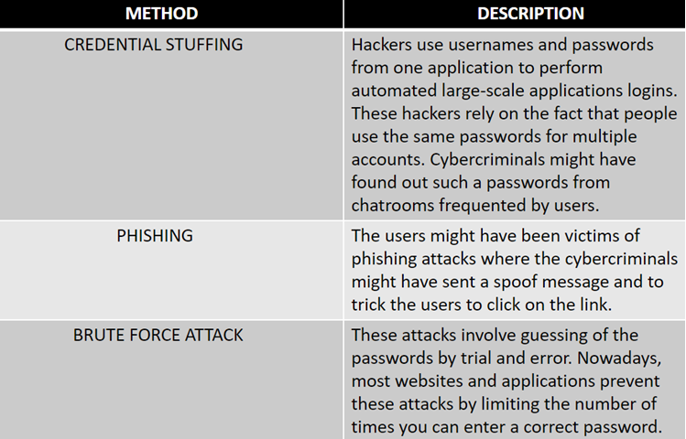

**Table 4.2.3.1** : Three possible scenarios

In response to the cyber attack -

* Nintendo discontinued NNID support.
* The passwords of affected accounts were reset.
* Advised users to set up two-step verification for logging into their accounts
* Testing for vulnerabilities.

**CHAPTER-5**

**PROJECT OUTCOME AND APPLICABILITY**

**5.1: OUTLINE**

This section encompasses the achievements of the team in collecting and grouping relevant data surrounding the project, so as to establish the required applicability of this research. This was done by conducting a thorough and detailed survey along with extensively analyzing the survey’s results to draw necessary and pertinent inferences.

**5.2: SURVEY**

Surveys help us analyze the general public opinion, understand their awareness of a particular subject, and attract their attention towards the details and specifications of a topic. It is an inexpensive and flexible method to spread information and gain insights into opinions and preferences. More importantly, it is a valuable tool, used to gather data. Through our project, we wanted to understand the various threats faced by online gaming platforms. While analyzing various research papers we came across the fact that online games are the future. Along with its rise are the rising threats faced by the gamers. We wanted to see if the general public is familiar with this growing issue. Hence, we conducted a survey to investigate how much people are aware of the recent cyber attacks, common threats and its destructive nature. The following are the results of the survey: -

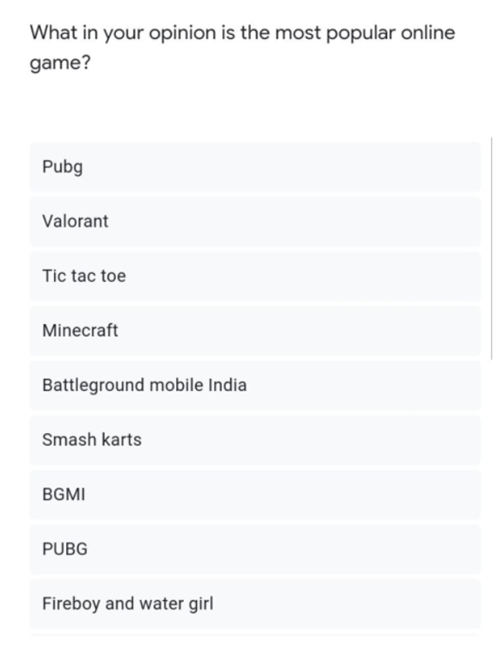

**Figure 5.2.1**: What in your opinion is the most popular online game?

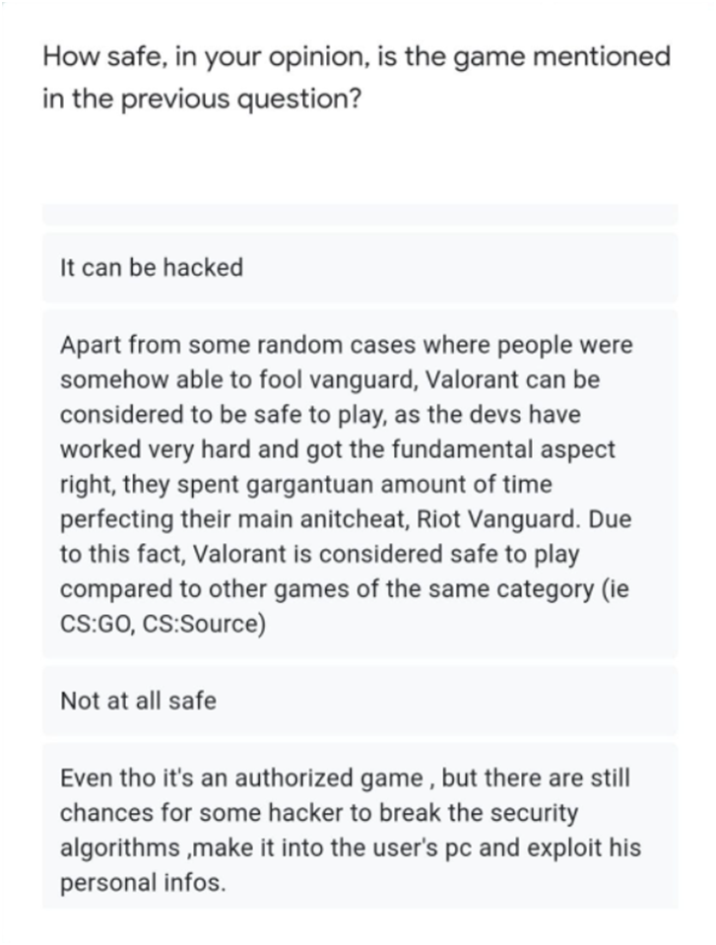

**Figure 5.2.2**: How safe in your opinion, is the game mentioned in the previous question?

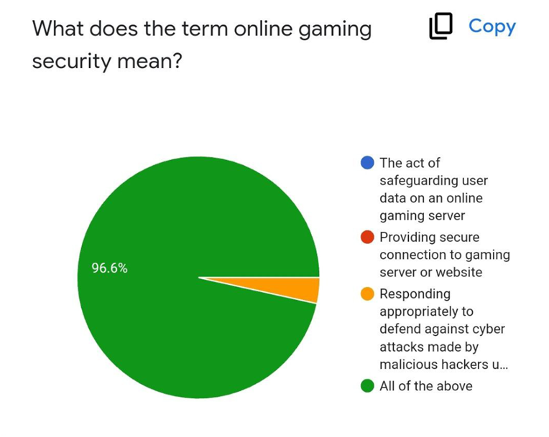

**Figure 5.2.3:** What does the term online gaming security mean?

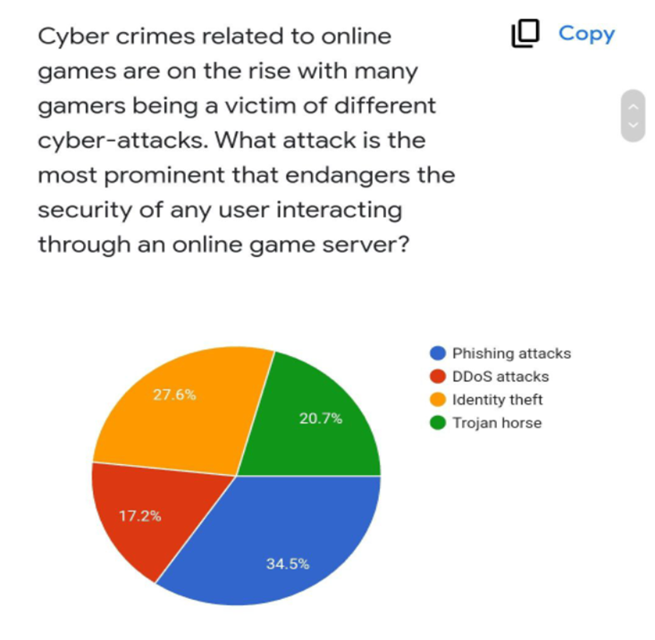

**Figure 5.2.4:**Cybercrimes related to online games are on the rise with many gamers being a victim of different cyber-attacks. What attack is the most prominent that endangers the security of any user interacting through an online server?

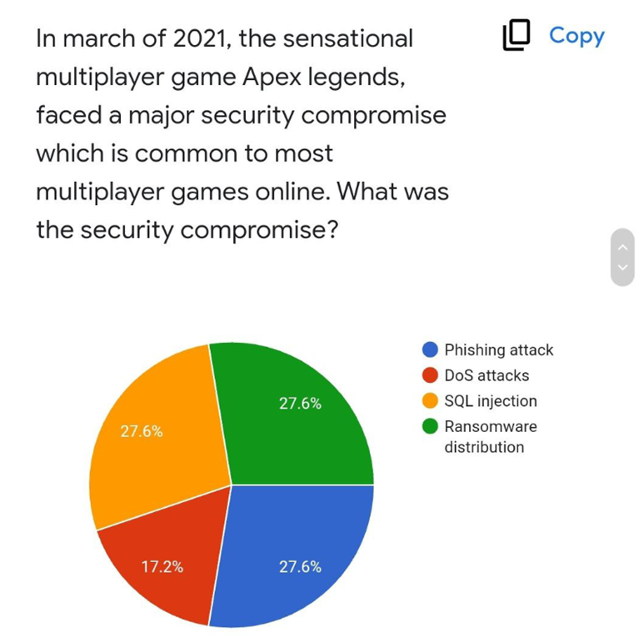

**Figure 5.2.5**: In march of 2021, the sensational multiplayer game Apex legends faced a major security compromise which is common to most multiplayer games online. What was the security compromise?

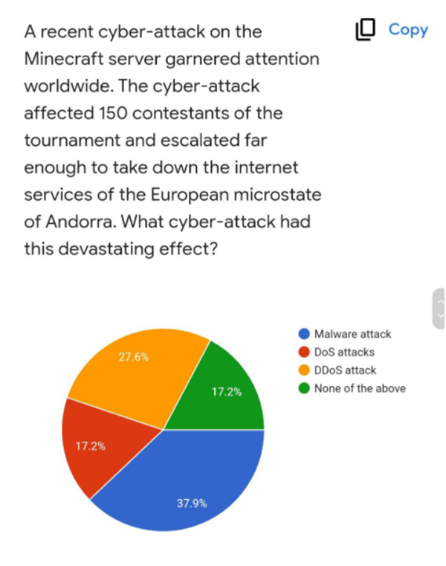

**Figure 5.2.6:** Which Cyber-attack affected the Minecraft server?

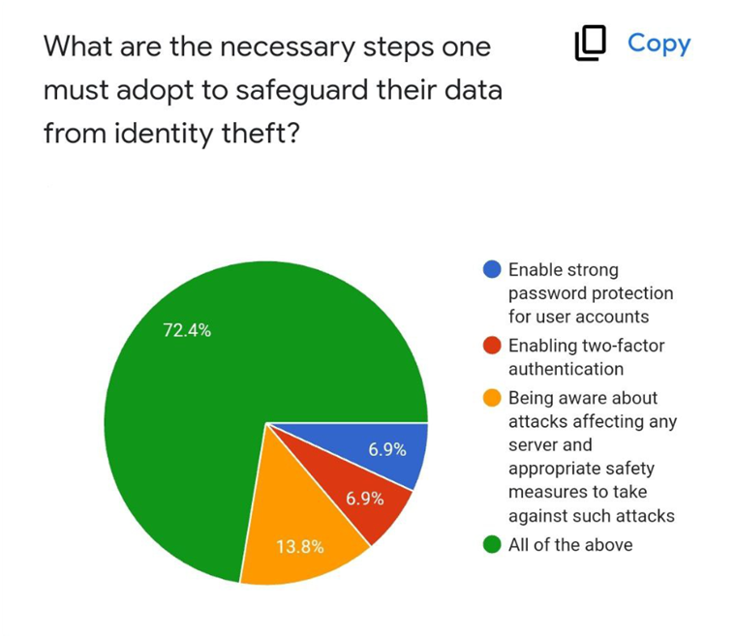

##### **Figure 5.2.7:** What are the necessary steps to safeguard their data?

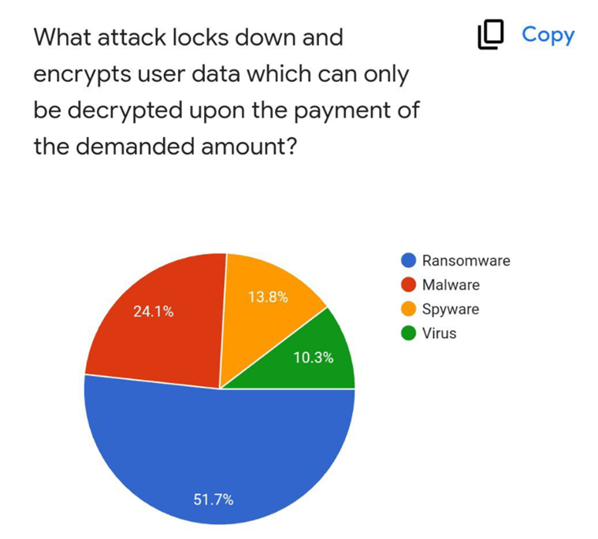

**Figure 5.2.8:** What attack locks and encrypts data and can be decrypted only by payment?

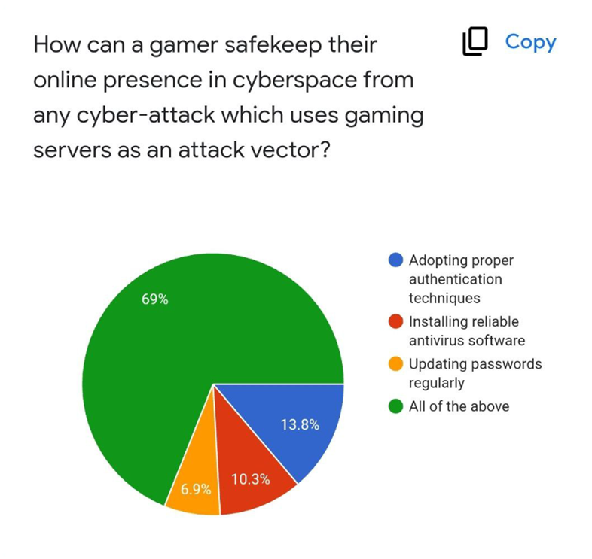

**Figure 5.2.9:** How can a gamer safe-keep their online presence in cyberspace

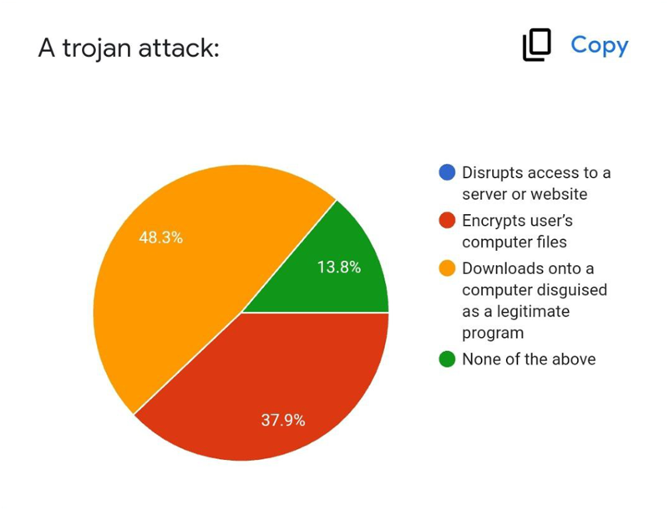

**Figure 5.2.10:** A Trojan Attack

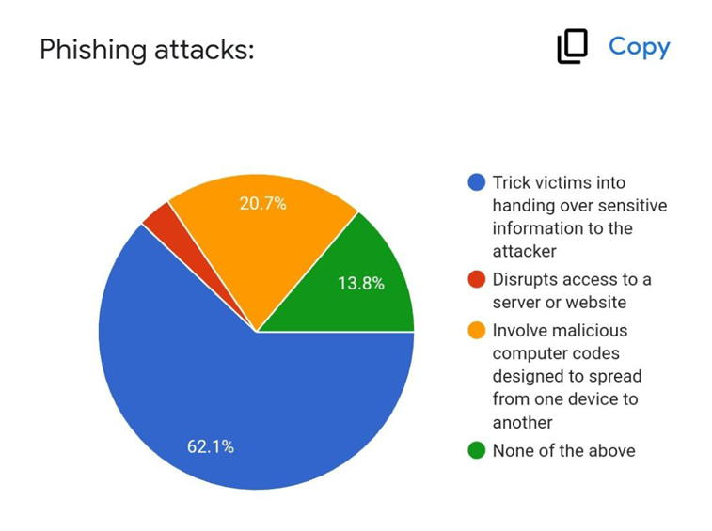

**Figure 5.2.11:** Phishing Attacks

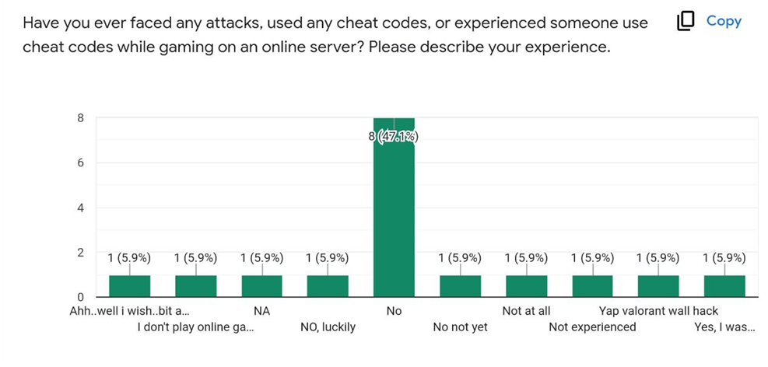

**Figure 5.2.12**: Have you ever faced any attacks?

Upon analyzing the results, we observed that people knew about the basics involving an online game. They have also played various common games like Valorant, Pubg, Fireboy, and Watergirl. 96.6 % of surveyees know the basic definition of online gaming security, while only 72.4% know how to completely protect their data.

People might have had a basic idea about online games and even played them, but when asked questions about the current threats faced by organizations, they were unable to answer them, even though those games are popular. For example, when asked about common attacks faced by a popular gaming platform called Apex legends, only 17.2% of people could correctly answer the DDoS attack. When asked about a very vicious attack involving Minecraft, which took down the internet of a microstate, only 27.6% knew that the correct answer was the DDoS attack.

When the surveyees were questioned about common attacks faced not only on gaming platforms but are common in the online world, many did not know about them. When asked about Ransomware, a common cyber threat that is on the rise, only 51.7% knew how it functioned. 62.1% knew what a phishing attack is, while only 48.3% knew what Trojan attacks are.

When asked about how we can safely keep our online presence, 6.9% thought that by updating our passwords regularly, we can protect ourselves, 10.3% thought that downloading an antivirus can protect us, 13.8% thought by adopting proper authentication techniques, while 69% of the surveyees marked all of the above.

Common feedback which we got while conducting the survey was that people found it difficult to answer a lot of the questions, and the questions made them think deeply about this topic. In conclusion, the general public needs to have more knowledge about security in online games and know about various ways to protect themselves in this era of technology.

# **CHAPTER - 6 CONCLUSIONS AND RECOMMENDATION**

* 1. **6.1 OUTLINE**

In this project report, we have explored the A-Z of Security in Computer Games; from the to its application in, acting as a lucrative business model for the cybercriminals and the nightmare for the various business and service organizations.

This paper approaches the study of, to understand the evolution of ransomware from various parameters, not limited to but including its diverse variants, method of deliverance, the attack vector, impact it had on affected data and timeline to remove the ransomware. The paper includes literature reviews of the recent research done around security in online, networked and other types of computer games, thereby acting as a cumulative resource for further studies or reference.

The paper also features case studies of, it concludes with a minor survey on the awareness of insecurities of gameverse and the opinions on this rising industry by the general public.

* 1. **6.2 LIMITATIONS AND CONSTRAINTS IN THE RESEARCH**

Any report based on data and facts is eventually constrained on the data available. In the field of Cyber Security, various variables occur that often do not provide the complete picture of the event and hence may lead to distorted facts and thereby we must rely on various assumptions in the statistics and trust the data provided by the organizations and the nation states.

The numerous examples/cases when and how the data differs have been discussed further.

**6.3 FUTURE ENHANCEMENTS**

This project report is currently limited to the data available till 23rd April, 2022. As the world becomes more aware of the insecurities in the gaming arena and its direct implications on the daily life of the people, nation states would have to develop stringent security policies and laws and organizations would have to publicly disclose their confrontations with such situations to tackle these issues.

**6.4 INFERENCE**

After studying so much about games and the technology safeguarding it along with reviewing papers on it, we have learnt that a serious approach and an unforgiving outlook is required. Cyber Security researchers continuously need to monitor software and system infrastructure along with patching vulnerabilities. Everyday new vulnerabilities are found and these need to be patched quickly to avoid severe consequences. To conclude with this paper, listed below are some of the preventive measures to ensure a secure gaming experience:

* Do not open spam mails or emails from unknown senders.
* Do not click on links within emails if you are not sure what it is about.
* Never download attachments within unknown emails.
* Use antivirus software and update it regularly.
* Disconnect Internet connection when not in use.
* Avoid clicking on greedy advertisements on websites.
* Make sure that the web browser software is updated and never install any unknown plugins.
* Browse and download software only from trusted websites.

The combination of law enforcement activity, more effective cybersecurity spending, and better controls put in place by cyber insurance companies may contribute to the decline.

This data is very comprehensive, but it is a trend that bears watching and something we will continue to monitor and update.

**REFERENCES**

1. Eric J. Hayes, *“Playing it Safe: Avoiding Online Gaming Risks”*, 2006 by US-CERT, a government organization <https://www.cisa.gov/uscert/sites/default/files/publications/gaming.pdf>
2. Jiyoung Woo,Graduate School of Information Security, Korea University and Huy Kang Kim,Graduate School of Information Security, Korea University, *“Survey and Research Direction on Online Game Security”*, 2012 ACM 978-1-4503-1835-8/12/0011 <https://dl.acm.org/doi/abs/10.1145/2425296.2425300>
3. Ying-Chieh Chen,Information Security Group, Institute of Information Technology, NRC, Canada, Patrick S. Chen, Information Management Department, Central Police University, Taiwan, Ronggong Song, Information Security Group, Institute of Information Technology, NRC, Canada, and Larry Korba, Information Security Group, Institute of Information Technology, NRC, Canada, *“Online Gaming Crime and Security Issue – Cases and Countermeasures from Taiwan”*, Proceedings of the 2nd Annual Conference on Privacy, Security and Trust. Fredericton, New Brunswick, Canada. October 13-15, 2004. NRC 47401, <https://www.researchgate.net/publication/220919991_Online_Gaming_Crime_and_Security_Issue_-_Cases_and_Countermeasures_from_Taiwan>
4. Bo ̈rje Felipe Fernandes Karlsson and Bruno Feijó, ICAD/IGAMES/VisionLab Computer Science Department - PUC-Rio, Rio de Janeiro, RJ - Brazil, *“An overview on security in networked computer games”*, EstudosInterdisciplinaresemComputac ̧a~o 15(2): 166--173, julho/dezembro, 2004 by Unisinos<https://www.researchgate.net/publication/275036437_An_overview_on_security_in_networked_computer_games>
5. Dwip Makwana, *“Security in Gaming”*, Volume 8 Issue V May 2020, ISSN: 2321-9653; IC Value: 45.98; SJ Impact Factor: 7.429, International Journal for Research in Applied Science & Engineering Technology (IJRASET)
6. Sanjana A and Medha Vinod ISE Department, NHCE, Bangalore, Karnataka, India, *“A Survey on Distributed Denial of Service Attacks in the Online Gaming Industry”*, 2020 IJSRCSEIT | Volume 4 | Issue 11 | ISSN: 2456-3307, <https://ijsrcseit.com/paper/CSEIT203113.pdf>
7. Gary Mcgraw, Cigital and Greg Hoglund, HBGary, *“Online Games and Security”*, published By the IEEE Computer Society 1540-7993/07 2007 IEEE, IEEE SECURITY & PRIVACY, https://www.researchgate.net/publication/232620828_Online_Games_and_Security_Issues\
8. Jiankun Hu, School of Computer Science and IT, RMIT University, 376-392 Swanston Street, Melbourne, Victoria 3001, Australia, Fabio Zambetta, *“Security issues in massive online games”* SECURITY AND COMMUNICATION NETWORKS Security Comm. Networks. 2008; 1:83–92 Published online in Wiley InterScience (www.interscience.wiley.com) DOI: 10.1002/sec.5
9. Chen Zhao, School of Computer Science, Wuhan University, Wuhan 430079, China, *“Cyber Security Issues in Online Games”*, Advances in Materials, Machinery, Electronics II AIP Conf. Proc. 1955, 040015-1–040015-5, Published by AIP Publishing. 978-0-7354-1654-3,<https://aip.scitation.org/doi/pdf/10.1063/1.5033679#:~:text=Common%20cyber%20security%20problems%20in,enhance%20the%20gaming%20user%20experience.>
10. Survey - <https://forms.gle/YcUnXovwyJEZmzdB9>
11. <https://www.sportskeeda.com/esports/respawn-addresses-apex-legends-ddos-attacks-fixes-server-vulnerabilities-bans-31-hackers>
12. https://www.bleepingcomputer.com/news/security/capcom-ransomware-gang-used-old-vpn-device-to-breach-the-network/
13. <https://www.eurogamer.net/capcom-concludes-ransomware-investigation-details-what-happened#:~:text=Having%20established%20a%20new%20Technology,improved%20management%20methods%20for%20VPNs>.
14. https://www.capcom.co.jp/ir/english/news/html/e210413.html
15. <https://www.invenglobal.com/articles/15279/apex-players-win-longest-match-in-history-due-to-ddos-attack>
16. <https://charlieintel.com/a-surprise-apex-legends-update-provides-unusual-fix-for-ddos-situation/108448/>
17. <https://www.gamesradar.com/apex-legends-developer-is-working-on-fixing-ddos-attack-after-banning-31-attackers/>
18. <https://www.eurogamer.net/respawn-making-huge-steps-towards-fixing-ddos-problem-in-apex-legends>
19. https://teampassword.com/blog/what-happened-during-nintendos-data-breach-in-2021#:~:text=In%20April%202020%2C%20Nintendo%20was,compromised%20accounts%20after%20further%20investigation.
20. <https://securelist.com/game-related-cyberthreats/103675/>
21. <https://isacybersecurity.com/cybersecurity-in-the-gaming-industry/>
22. <https://www.digitalshadows.com/blog-and-research/cyber-threats-to-the-online-gaming-industry/>
23. <https://www.securitymagazine.com/articles/93764-the-pressures-the-online-gaming-community-faces-when-it-comes-to-cybersecurity>
24. <https://www.mygreatlearning.com/blog/the-gaming-industry-saw-cyber-attacks-spike-during-the-pandemic/>
25. https://www.bitdefender.com/blog/hotforsecurity/ddos-attack-on-minecraft-twitch-tournament-disrupted-andorras-internet-access/
26. https://www.worldatlas.com/maps/andorra
27. https://webmediums.com/news/the-squid-game-minecraft-event-will-have-a-prize-of-100-thousand-dollars-ceet3kdm8weg